**Signs of digital distress: Mapping broadband availability and subscription in American neighborhoods**

Adie Tomer, Elizabeth Kneebone, and Ranjitha Shivaram

**Executive summary**

The internet is now a fundamental component of the American economy, creating new ways to educate, employ, bring services to, and entertain every person. Broadband, especially wireline broadband in American homes, is the essential infrastructure for unlocking the internet’s economic benefits. However, broadband infrastructure is far from ubiquitous, both in terms of where it operates and who subscribes to it, and those deficits are not shared evenly across the country. As such, policymakers have a responsibility to understand a national digital divide that has different contours depending on the place.

Using data from the Federal Communications Commission and the American Community Survey, this paper assesses broadband’s deployment and consumer subscriptions at the census tract level. It finds:

***As of 2015, broadband services were available to 93 percent of the nation’s population, but large availability gaps existed in lower-density areas.*** In December 2015 the vast majority of residents in the United States lived in communities served by wireline broadband that offered download speeds of at least 25 Mbps. However, more than 22 million people lacked such services in their neighborhoods. Geography, rather than demographic characteristics, is the predominant factor determining broadband services available to them: more than half of residents who lack access to broadband live in rural America.

***Most major metro areas offer near complete broadband coverage to their residents, but lower-density, more agriculturally focused regions in the South and West lag behind.*** Among the 100 largest metro areas, five in Florida and five others—ranging from Akron, Ohio to Salt Lake City—have achieved 100 percent broadband coverage for their residents. Yet even among metro areas with near universal broadband availability, deployment gaps can leave tens of thousands of residents without the option of broadband.

***Over 73 million people (23 percent of the nation’s population) live in neighborhoods where in-home broadband subscription rates fall below 40 percent.*** In contrast, just 18 percent of the nation live in neighborhoods where subscription rates exceed 80 percent. Neighborhoods most likely to lag behind are those with lower incomes, lower educational attainment levels, and an aging population.

***Nearly every large metro area includes neighborhoods with subscription rates below 40 percent, but the gaps are largest in less dense regions.*** Over half of the population in metropolitan McAllen, Texas, Albuquerque, N.M., and Boise City, Idaho live in neighborhoods where subscription rates fall below 40 percent. Conversely, in metropolitan Washington, Honolulu, and four other metro areas, over half the population lived in neighborhoods with subscription rates over 80 percent.

***Eighteen of the 20 metro areas that rank highest on a combined index of broadband availability and subscription are in Florida, the Northeast, and the Pacific Coast.*** Top performers include some of the nation’s largest metro areas like New York and San Francisco, but also relatively smaller places like Palm Bay, Fla. and Oxnard, Calif. Conversely, 15 of the 20 lowest-ranking metro areas lie largely in the Southeast and Great Plains.

While the nation still falls short of complete broadband coverage—especially in rural America— geographic and demographic disparities in who subscribes to wireline broadband drive today’s digital divide. Addressing the availability and subscription gaps that limit economic opportunity in specific neighborhoods requires a balanced policy framework and collaborative partnerships between the private, public, and civic sectors. Considering that broadband is essential infrastructure in today’s digital economy, the status quo limits American competitiveness and equitable access to economic opportunity.

**Introduction**

Less than two decades into the new century, the internet is already an unquestioned foundation of the modern American economy and the American home.

Much as with the introduction of electricity in the 20th century—an innovation that changed how people lit their rooms, cooked their food, washed their clothes and dishes, and entertained themselves—the internet is redefining how the 21st century household operates. Job seekers can scan online job boards and socially network with colleagues. Internet-connected applications allow families to control their lights and thermostats from anywhere in the world. Internet-based companies can ship fresh dinner ingredients straight to front doors, or households can order carryout via internet-connected devices. Each year, more people use the internet to stream videos and play games.

Like electricity, the internet can also substitute for entire tasks that used to require a trip outside the home. Streaming video and digital blackboards create virtual classrooms in any room with a computer. Video conferencing and remote file access redefine what a home office can be. Telemedicine even brings health care into the home.

A high-speed internet connection—what’s known as broadband—is the newest essential infrastructure. But to maximize its economic potential, broadband must be both physically available to and adopted by every home. These twin objectives stand at the center of national policy via the National Broadband Plan.[1]

Based on the transformative power of the internet, researchers inside and outside government have long understood the importance of mapping broadband availability and adoption. The existence of significant shares of households without a connection or subscription came to be known as the digital divide, and regular studies of the national digital divide since the late 1990s created a benchmark for U.S. broadband penetration.[2] But because broadband deployments and subscription patterns can vary significantly from one neighborhood to the next, these national studies say little about local conditions and needs.

This report generates new measures of the digital divide by using neighborhood-level indicators to assess national *and* local measures of in-home broadband availability and adoption. In the process, the findings create a more granular view of broadband needs across the country.

The report begins by outlining broadband’s importance to the American economy and current perceptions of the digital divide. After a brief review of methodology, the first two findings compare broadband availability at both the national and local levels. The following two findings assess what is driving broadband subscription and where gaps exist at the neighborhood and metropolitan scale. The fifth finding offers a composite ranking—combining availability and subscription—of the largest metro areas. The report concludes with a set of policy implications for all governmental levels.

**Definitions**

***Availability*—**The Federal Communications Commission (FCC) considers fixed broadband connections to be available in a specific geography if the service provider can provide two-way data transmission to end users at or above the specified speed that is typical for that type of connection.[3] In this report, availability of fixed, wireline broadband connections is used to denote whether the majority of a census tract’s residents can access fixed, wireline broadband service at or above the specified speed. Availability is sometimes also referred to as coverage and used in conjunction with the phrase “broadband deployment.” For instance, the FCC uses a metric called the deployment rate, which is “the ratio of the population with access to fixed broadband service at or above the specified speed to the total population.”[4]

***Subscription*—**In this report,the rate of subscription is the share of a census tract’s population with a fixed subscription of a specific speed. Subscription is a major component of the broader concept of broadband *adoption*, which also considers whether an individual uses broadband.

**Background**

Broadband is an inherently flexible term. Intrinsically, it refers to a high-speed connection to the internet that is always available. Yet as digital telecommunications continue to evolve, so too do definitions of what qualifies as broadband-level speeds. Moreover, the term is not limited to only one transmission technology. Any of the multiple technologies that deliver digital telecommunications to end users—including digital subscriber lines (DSL), cable, fiber, or satellite—can qualify as broadband.

This paper specifically focuses on wireline broadband.[5] While wireless data plans have exploded in popularity since 2011, wireline broadband continues to offer multiple benefits to household users.[6] Specifically, it delivers higher connection speeds, permits greater cross-platform security, typically includes unlimited data, and maximizes a mobile device’s utility via high-speed WiFi.[7] As such, wireline broadband is a critical, in-home gateway to the content, applications, and services that enable households to participate in a digital economy.[8] Additionally, there is a concern that individuals who rely exclusively on wireless plans—and who tend to be lower income, younger, and more racially diverse—are limited in their capacities to tap the internet’s potential.[9]

***How does wireline broadband work?***

Most households see broadband only as the cable or telephone line running from a socket in their wall to a modem and, increasingly, to a WiFi router sending signals across their home. But delivering wireline broadband to homes relies on an expansive collection of fixed telecommunications infrastructure (Figure 1).

The process begins with internet backbone infrastructure, internet exchange points (IXP), and points of presence (PoP)—the privately held cables and exchanges that connect in-home devices to servers across the world. While private internet service providers (ISPs) and other telecommunications firms are responsible for constructing such long-distance infrastructure and ensuring its stable operation, any access to and construction along public rights-of-way—typically streets—requires permission of the relevant government authority. Whether the cables cover long distances or sit within local broadband infrastructure, and whether cables run under streets or from telecommunications poles, connecting private homes and larger buildings to global broadband infrastructure requires rights-of-way access. All along the way, different levels of government carry different responsibilities to regulate the physical delivery of internet data to the end user. Figure 1 details some of the major responsibilities, and Appendix A describes them in more detail.

**Figure 1: Fixed broadband infrastructure system in the United States**

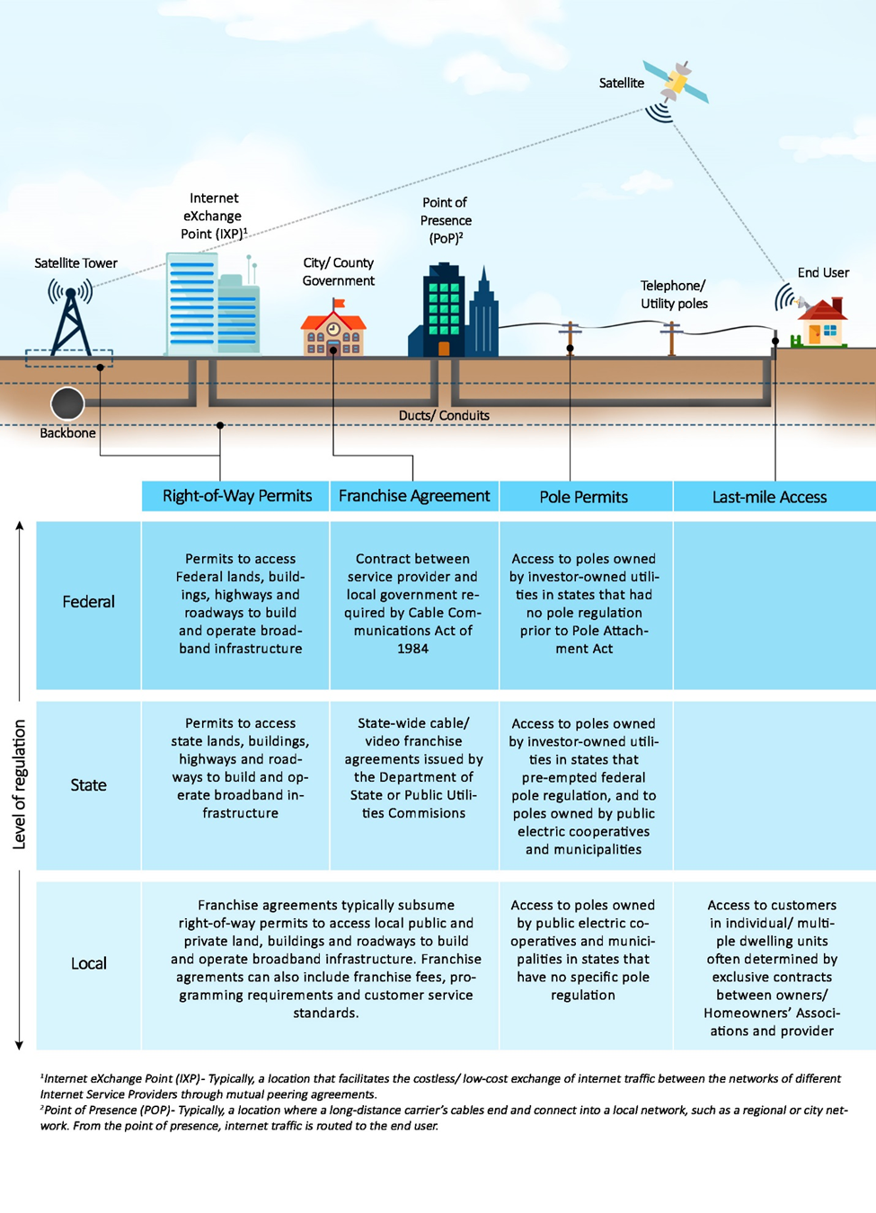

*Source: Brookings Institution.*

While complex in nature, the system of privately managed infrastructure and public regulation depicted in Figure 1 created a platform that allowed most of America to go online. As of June 2016, there were 104 million fixed internet subscriptions in the United States.[10] Although this figure does not discern by speed, it does reflect the roughly 73 percent of adults who subscribe to wireline broadband service.[11]

***Why does wireline broadband matter?***

As wireline broadband deployment grows, both in terms of physical reach and speed thresholds, macro- and microeconomic outcomes are increasingly intertwined with the digital innovation enabled by reliable, fast, and secure internet connections in American homes.

The internet is now an indispensable resource for workers, both actively employed and seeking employment. As of 2015, 79 percent of Americans who looked for work in the last two years used online resources and information in their job searches.[12] At the same time, telecommuting has become a tangible alternative to onsite work: in 2016, 24 percent of Americans did some or all of their work at home on the days that they worked, with the percentage rising to 34 percent for management workers.[13] Creating materials for job applications, searching for employment, and working from home are all made possible by wireline broadband. Of course, the modern workplace—including service, manufacturing, and government industries—all rely on dependable broadband to execute their work.

Regional broadband also helps grow the United States’ advanced industries. Relying on a combination of workers trained in science, technology, engineering, and math (STEM) and relatively large R&D investment, the country’s 50 advanced industries employ about 9 percent of all workers, and the average pay is nearly twice that of jobs outside the supersector.[14] These knowledge-intensive firms often choose their locations based on broadband availability.[15] An in-home broadband connection enables workers to develop their digital skills and become valuable assets to these digitally connected industries—and then telecommute once on the job.

Beyond the workplace, wireline broadband provides access to many activities that are integral to the well-being of American households. Commerce has gone digital, with around eight in 10 Americans now shopping online, 15 percent of them on a weekly basis.[16] The same transition is underway with in-home entertainment, where roughly 75 percent of non-Baby Boomers subscribed to a video streaming service in 2017.[17] Similarly, 70 percent of Americans use social media to connect with one another, read news content, share information, and entertain themselves.[18] Wireline broadband also carries the majority of cellular data, showing how the more communication-driven functions of smartphones tend to rely on WiFi and other connections to fixed infrastructure.[19]

These direct benefits to households combine to create significant aggregate economic benefits, too. Broadband helps metropolitan areas attract top talent from around the world and thus boosts their long-term competitiveness.[20] Within a community, broadband can raise home values and, in the process, increase local tax revenues.[21] Research also consistently finds that broadband—including in-home connectivity—helps add jobs, business establishments, and a more diverse industry mix.[22] Greater broadband adoption can even raise per capita incomes across entire countries.[23] Getting more people online within a community can address issues of data poverty and create cost savings for government operations.[24] Based on this research, plus more featured by the White House Council of Economic Advisors, broadband is a powerful and necessary economic engine for the digital age.[25] But the question remains: will it be an inclusive force, or will it only deepen disparities between socioeconomic groups?

***Why is it important to understand broadband deployment and subscription at the neighborhood scale?***

Neighborhood-level analyses of broadband infrastructure and uptake are essential for better identifying and addressing deployment gaps within regions, municipalities, and rural counties. At the same time, disaggregating metrics on the digital divide down to the neighborhood level also allows policymakers and practitioners to more effectively target their limited resources to boost adoption among the lagging populations and neighborhoods that stand to benefit most from those efforts.

Neighborhood-level broadband conditions can indicate which neighborhoods are most likely to be left behind in a digital era. Chicago’s multiyear Smart Communities program—which offered digital literacy and other training in targeted, low-income neighborhoods—proved that more residents will access job and health care services when they receive a neighborhood-wide intervention to promote broadband use.[26] These promising results suggest that getting entire neighborhoods online can lead to greater economic outcomes, but they also confirm that neighborhoods struggling with broadband subscription are important focus areas for inclusive economic development planning.

There may also be a case for further study to understand the “neighborhood effects” of broadband deployment and subscription, much like work around neighborhood concentrated poverty.[27] For instance, neighborhood broadband conditions—the presence of broadband connectivity and total subscription levels within a small geography—could create spillovers that impact the entire population in those neighborhoods and even the broader region. Much like the broader phenomenon of network effects within the infrastructure sector, the more (or less) people who can access and subscribe to broadband the better (or worse) a neighborhood will be situated across multiple critical policy dimensions.

Consider education. Since school catchment areas tend to match neighborhoods in size, schools serving neighborhoods with either poor broadband availability or lower broadband subscription rates will face distinct challenges in executing a digital curriculum. This is especially the case for one-to-one device programs, which provide every student with a mobile computing device.[28] While the devices’ broadband capabilities likely can be used within school facilities, many students will not be able to tap their device’s full potential once they go home. The opposite is then true for schools (or entire school districts) where every child lives with an in-home broadband connection. Those schools will more easily execute digital curricula, to the long-term benefit of all students.

Limited broadband service and subscription rates can increase costs for government service programs that rely on targeted delivery. Consider food assistance programs that may want to streamline food deliveries and attract the most at-risk populations, or job training programs that could be delivered remotely to interested individuals. Clusters of non-broadband subscribing individuals will slow local governments’ transition to such digital programs, resulting in higher costs and limited effectiveness. Such higher costs impact entire communities that must pay more for public programs that offer the same level of service (or less) as those in more digitally connected places.

Such questions merit additional research. Not only does the following analysis provide a baseline understanding of neighborhood conditions that could help inform those inquiries, but it also offers immediately informative and actionable metrics for policymakers and practitioners looking to close deployment and subscription gaps in their communities.

***The persistent digital divide***

Even with the immense benefits in-home broadband brings to people and their neighborhoods, broadband access and adoption are not ubiquitous. Since at least the late 1990s, researchers have used the digital divide framework to study these dual challenges.[29]

From the supply side, market dynamics impact private-sector deployments.[30] Since telecommunications firms need revenues to justify infrastructure construction and operation, population density and average income affect availability in critical ways.[31] In particular, far-flung and sparsely populated rural areas are often underserved relative to their metropolitan peers.[32] Competition can also significantly influence the quality of service offered, especially for minority groups.[33] Even up against these equity hurdles, broadband deployment has seen a significant uptick, and the quality of service continually improves.[34]

Broadband adoption is a more persistent challenge. Across a wide range of applied research, a consistent set of socioeconomic factors have been found to drive disparities in subscription rates.[35]

As the Pew Research Center’s long-running survey series regularly finds, price is a major adoption barrier.[36] Confirming this work, other research found that a 10 percent increase in subscribership could require a price reduction of as much as 15 percent.[37] These findings are especially concerning for those living in poverty, who may need targeted subsidies to connect to the digital economy within their homes.[38] One important consideration is the clear price gap between comparable broadband service in the United States and its developed peers (Figure 2).[39] Though the figure doesn’t take into account the fact that some domestic ISPs offer cheaper pricing plans at lower speeds, the general finding holds that U.S. broadband is relatively expensive. And while broadband pricing involves multiple, complex factors—including how firms must balance revenues and investment needs, and how countries approach regulation differently—boosting adoption will require balancing variable willingness and ability to pay among different populations.[40]

**Figure 2: Average price of fixed broadband plans per Mbps of download speed, by country, 2014 (US$)**

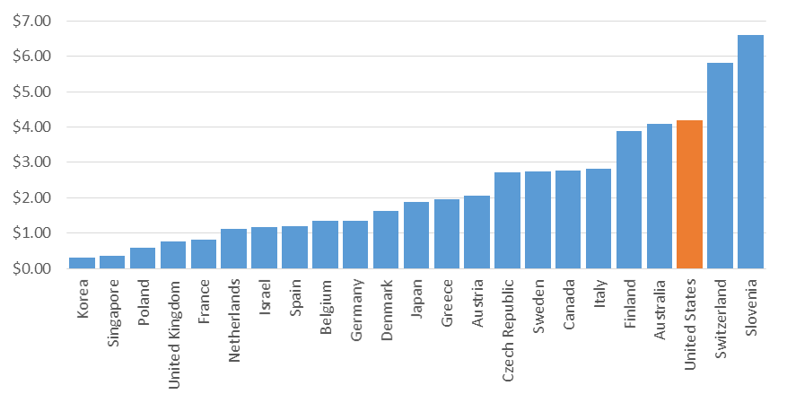

*Source: Federal Communications Commission, Fifth International Broadband Data Report, 2016.*

Digital readiness and access to equipment are other consistent adoption barriers. In this instance, digital readiness includes both digital skills—such as the ability to use digital hardware and software to manage information, communicate, navigate the internet, solve problems, and create content—and trust in digital platforms.[41] A lack of digital readiness is especially prevalent among older, non-Asian minority, less-educated, and lower-income individuals.[42] A lack of in-home computing equipment also functions as a major barrier, although community centers like libraries can function as substitutes.[43] Indeed, 97 percent of public libraries now offer free Wi-Fi access.[44] However, community internet access points may not lead to greater in-home adoption.[45] More troubling, a lack of in-home equipment can have a negative impact on school enrollment for youth.[46]

To develop effective and equitable policies that address the digital divide, governments at all levels must clearly understand where gaps exist, both in terms of availability and subscriptions. The following research provides just such a roadmap.

**Data and methods**

To assess the availability of wireline broadband service across places and population groups in the United States, and the extent to which people subscribe to broadband where it is available, we compiled fixed broadband deployment and subscription data from the FCC’s Form 477 and demographic data from the U.S. Census Bureau’s American Community Survey (ACS) for every census tract in the nation. Census tracts—often used as proxies for neighborhoods—represent the lowest level of geography for which the full complement of relevant FCC variables is available. To ensure that the data align temporally, we use Form 477’s December 31, 2015 dataset and the ACS 2015 five-year estimates.[47]

Together, these data allow us to analyze two key metrics:

***Availability****.* We determine whether broadband internet is available to (or has been “deployed” to) a neighborhood based on FCC data that identify the number of service providers offering fixed, wireline broadband services (i.e., high-speed internet service *not* delivered through mobile technologies) in each census block as of December 2015. We aggregate census block data up to census tracts to be consistent with the level at which the FCC reports subscription data (described in more detail below). We consider a census tract “covered” by broadband if at least half of its census block residents have the option to purchase fixed, wireline broadband-speed internet service from at least one provider. This method produces aggregate results extremely close to other national studies. In addition, it allows us to join tract-level demographic data from the ACS to the FCC data to assess population and neighborhood characteristics (e.g., education and income levels) not available at the block level. However, this approach does introduce a modest level of assignment error when looking at specific tracts.[48] Appendix B expands on this point.

We focus in particular on the 25 Mbps download speed threshold, as it is the current standard in the United States for determining what constitutes broadband.[49] In particular, this is the advanced speed to originate and receive high-quality voice, data, graphics, and video telecommunications. However, because the definition of broadband has evolved and continues to do so, we also consider patterns of availability according to alternative speed thresholds (e.g., 10 Mbps download speed, which is one prevailing international standard).

***Subscription****.* The FCC provides tract-level information on the share of residents that had subscribed to a fixed connection internet access service at download speeds of at least 10 Mbps and upload speeds of at least 1 Mbps as of December 2015.[50] Rather than reporting the actual proportion of households subscribing to a fixed service that meets those speed thresholds, the FCC assigns each tract to one of six subscription categories: 0 percent, 0 to 20 percent, 20 to 40 percent, 40 to 60 percent, 60 to 80 percent, or 80 to 100 percent.[51]

For the purposes of this analysis, we collapse these demarcations into three tiers of subscription. By our definition, a *low subscription* neighborhood is one where fewer than 40 percent of households subscribed to broadband as of December 2015 (or, put differently, a neighborhood where most households did not subscribe to broadband). A *moderate subscription* neighborhood had adoption rates between 40 and 80 percent, and a *high subscription* neighborhood had more than 80 percent of its households connected to high-speed, fixed service by the end of 2015. Recognizing that subscription levels are undoubtedly influenced by the extent to which broadband service is available in a neighborhood in the first place, the analysis in the paper’s final finding combines both availability and subscription metrics.

Using these tract-level availability and subscription designations in combination with tract-level ACS data, we assess the size of the population (both numbers and shares of people) living in neighborhoods with and without broadband service and in neighborhoods with low, moderate, and high subscription rates, as well as the characteristics of those residents (e.g., age, race, poverty status, educational attainment).

In addition to neighborhood measures of broadband availability and subscriptions, we also aggregate tracts to assess geographic patterns in the nation’s 100 most populous metropolitan areas, including in their major cities and surrounding suburbs. By our definition, cities include the first city in the official metropolitan statistical area title and any other city in the title with a population over 100,000, while suburbs account for the remainder of the metro area. We also report findings for the nation’s smaller metropolitan regions and rural communities (or tracts that fall outside of metropolitan statistical areas).[52]

Finally, all mentions of broadband speeds reference download speeds unless otherwise noted.

**Findings**

***Finding 1: As of 2015, broadband services were available to 93 percent of the nation’s population, but large availability gaps existed in lower-density areas.***

After multiple decades of build-out, broadband connections are now available to most of the population, but the variation in deployment at higher speed thresholds reveals growing gaps in availability (Figure 3). Nearly the entire population has the option to connect to the internet at slower speed tiers like 3 Mbps, but those speeds can restrict the ease of even basic web browsing.[53] Availability is nearly as high for 10 Mbps service, a level that could still limit certain multi-user and/or high-use web activity. The 25 Mbps threshold represents the official definition of “advanced telecommunications capability” in the FCC’s Broadband Progress Report. Here, availability drops again, but still exceeds 90 percent. Not until reaching gigabit-level speeds (see Box 1) does availability drop precipitously.

High coverage rates notwithstanding, small gaps in availability mean that millions of people across the country lack the option of subscribing to high-speed wireline service. Even at the 3 Mbps threshold, service failed to reach 2.2 million people in 2015. If the bar is raised to 10 Mbps, the number of residents without coverage triples, and it more than triples yet again using the 25 Mbps standard. Under that definition, 22.1 million people lived in neighborhoods that lacked broadband service in 2015.

**Figure 3: Broadband availability in the United States by advertised speed, 2015**

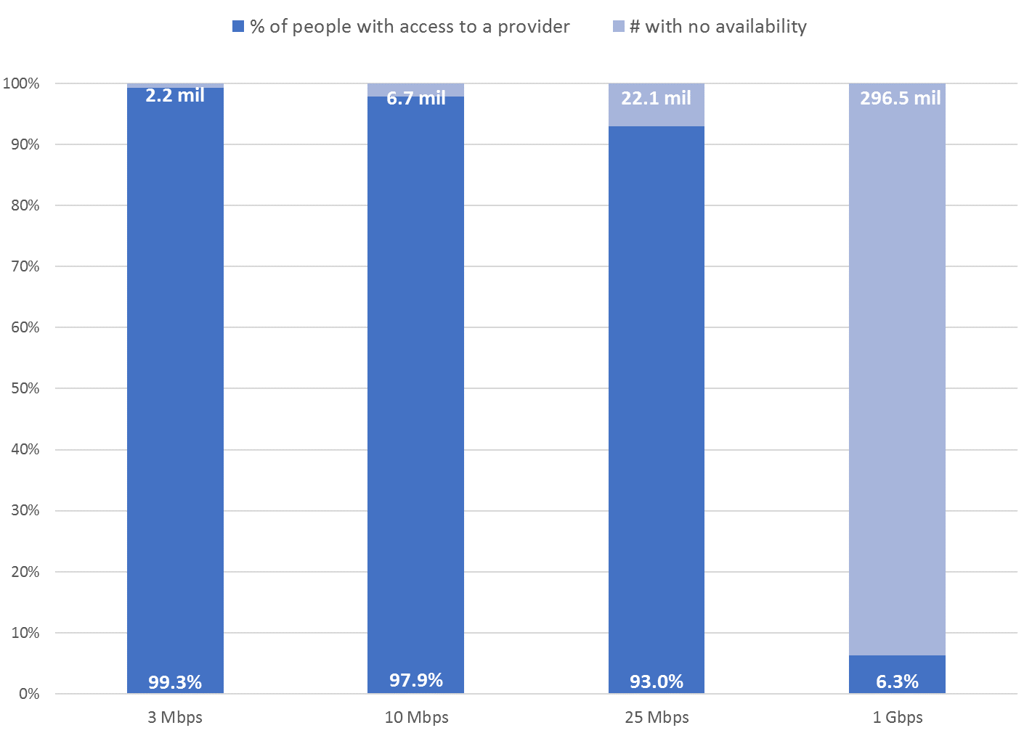

*Source: Brookings Institution analysis of 2011-2015 American Community Survey and FCC data.*

Those residents are not distributed evenly across the nation. As might be expected, denser parts of the country offer greater deployment of broadband service than less populous places. In the cities that anchor the nation’s 100 largest metro areas, more than 99 percent of the population lived in neighborhoods where at least one provider offered broadband at speeds of 25 Mbps or higher in 2015, leaving a gap of just 363,000 unserved residents (Figure 4). The suburbs of those regions followed closely behind, with a coverage rate of 97 percent, or a service shortfall of 4.2 million people. Small metro areas registered a coverage gap slightly above the national average at 8 percent, leaving 4.8 million residents without the option of broadband service.

By far, the largest broadband deployment gap exists in rural communities, where more than one in four residents (12.7 million people) lacked 25 Mbps broadband service in 2015. As Figure 5 illustrates, while rural communities are home to just 15 percent of the nation’s total population, they accounted for 57 percent of the nation’s residents in neighborhoods where broadband has yet to be deployed—a ratio that remains roughly the same at lower speed thresholds.

**Figure 4: Share of residents without 25 Mbps service in their neighborhoods**

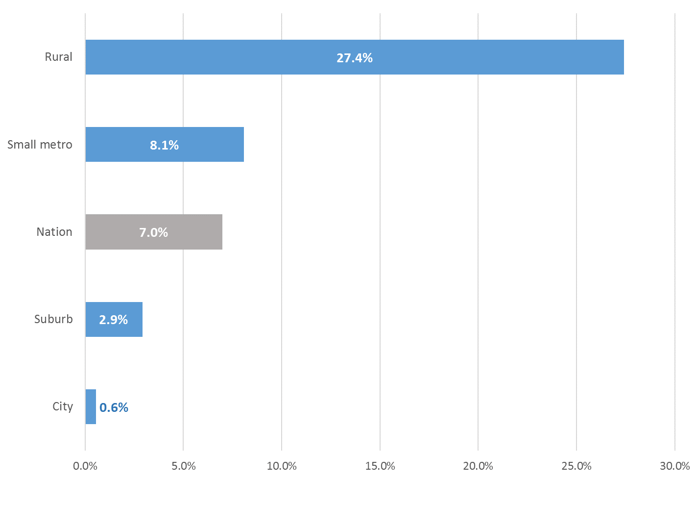

*Source: Brookings Institution analysis of 2011-2015 American Community Survey and FCC data.*

The heavily rural tilt to the broadband service gap makes sense given the challenges inherent in bringing wireline service to diffuse or sparsely populated communities. The average population density of neighborhoods in the nation’s cities was 14,639 people per square mile in 2010-2015, compared to just 467 people per square mile in the average rural neighborhood. (Suburban and smaller metro area neighborhoods fall in between the two, with respective averages of 3,858 and 2,054 people per square mile.[54])

**Figure 5: Geographic distribution of residents without 25 Mbps service in their neighborhoods**

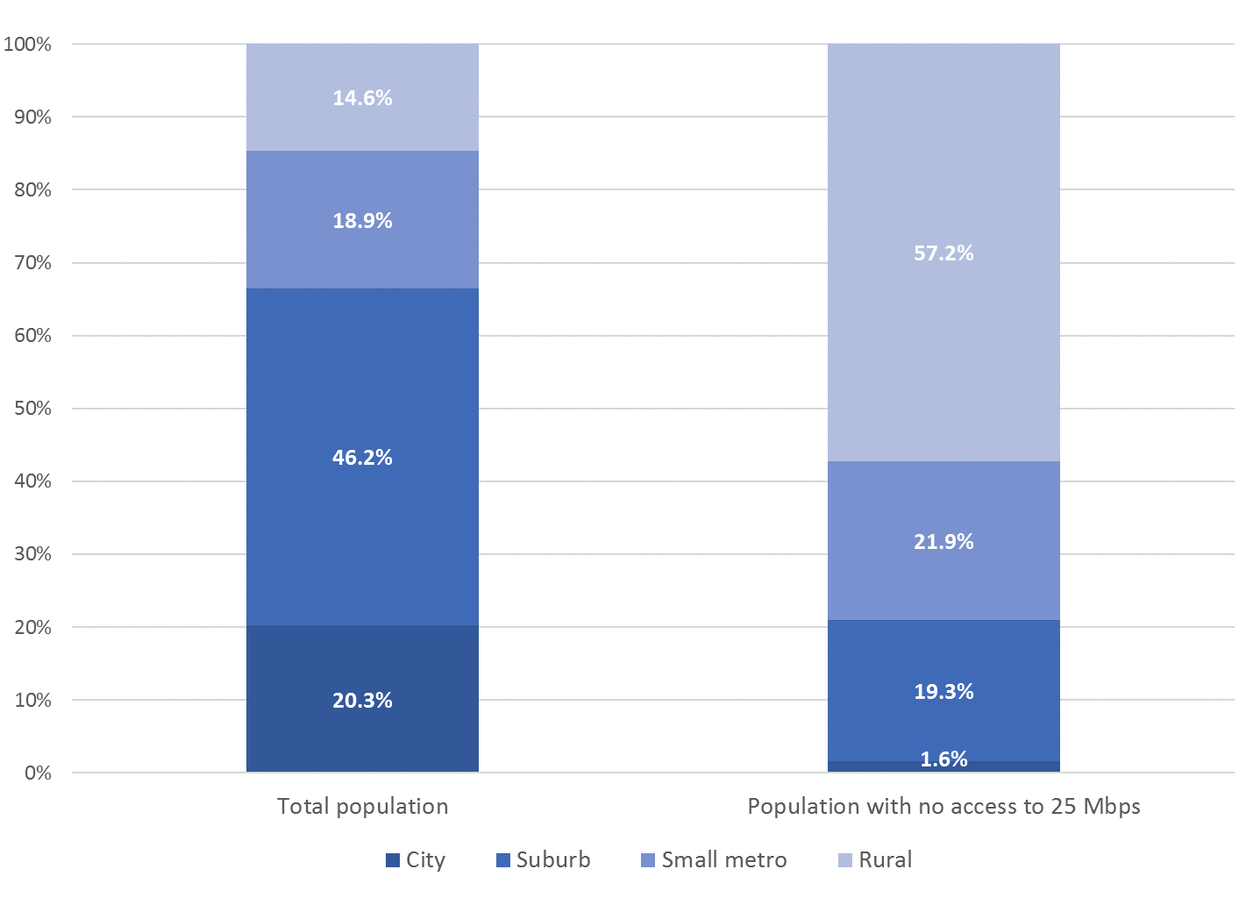

*Source: Brookings Institution analysis of 2011-2015 American Community Survey and FCC data.*

Indeed, any disparities in broadband deployment across different segments of the population appear to stem more from geography than demography (Table 1). It is true that, compared to the population as a whole, residents living in neighborhoods where broadband was not available were more likely to be born in the United States, to be white, and less likely to have completed college; they were also more likely to own their homes and to have a member of the household with a disability.

But those differences do not reflect a broadband service map that systematically disadvantages or advantages a particular demographic or socioeconomic group so much as they underscore demographic differences in the makeup of rural and urban America. Given the rural bent of the broadband availability gap, it is not surprising to see that the demographic and economic profile of the unserved population closely mirrors the composition of the rural population overall.

**Table 1: Characteristics of the population with no 25 Mbps service in their neighborhood**

|  |  |  |  |  |  |  |  |  |
| --- | --- | --- | --- | --- | --- | --- | --- | --- |
|  | **Total population** |  | **Population with no 25 Mbps service in their neighborhood** | |  | **Rural population** | | |
| ***Share of population that is:*** |  |  |  |  | | |  |
|  |  |  |  |  | | |  |
| Foreign born | 13% |  | **4%** |  | | | 4% |
|  |  |  |  |  | | |  |
| White | 62% |  | **76%** |  | | | 79% |
| Black | 12% |  | **9%** |  | | | 8% |
| American Indian, Alaskan Native, Native  Hawaiian, and Pacific Islander | 1% |  | **3%** |  | | | 2% |
| Asian | 5% |  | **1%** |  | | | 1% |
| Hispanic | 17% |  | **10%** |  | | | 8% |
|  |  |  |  |  | | |  |
| Under 18 years old | 23% |  | **22%** |  | | | 23% |
| 18 to 64 years | 61% |  | **60%** |  | | | 59% |
| 65 years or older | 14% |  | **16%** |  | | | 17% |
|  |  |  |  |  | | |  |
| A non-native English speaker with limited  proficiency | 9% |  | **4%** |  | | | 3% |
|  |  |  |  |  | | |  |
| At least a college graduate | 30% |  | **17%** |  | | | 18% |
|  |  |  |  |  | | |  |
| Unemployed | 5% |  | **5%** |  | | | 5% |
|  |  |  |  |  | | |  |
| Poor | 15% |  | **17%** |  | | | 18% |
|  |  |  |  |  | | |  |
| ***Share of households that are:*** |  |  |  |  | | |  |
|  |  |  |  |  | | |  |
| Owner occupied | 64% |  | **77%** |  | | | 71% |
|  |  |  |  |  | | |  |
| Family households | 66% |  | **70%** |  | | | 67% |
|  |  |  |  |  | | |  |
| Include a member with a disability | 25% |  | **32%** |  | | | 32% |
|  |  |  |  |  | | |  |
| Receive public assistance | 3% |  | **2%** |  | | | 3% |

*Source: Brookings Institution analysis of 2011-2015 American Community Survey and FCC data.*

When it comes to deploying broadband, it seems to be density, rather than demographics, that proves the strongest determining factor of the nation’s remaining availability gaps. That challenge holds even within the major metropolitan markets that are home to the majority of the nation’s population and economic activity.

**Box 1: Residential gigabit is still under construction**

Each year, data exchange becomes a more important process within the broader economy. Falling computer processing and data storage prices, cloud computing, connected video surveillance, and media streaming all combined to produce over 1 zetabyte of global internet traffic in 2016.[55] And with new features like the Internet of Things coming online, that number is expected to continue its exponential rise.

Gigabit broadband technology, which correlates with 1 Gbps (or 1,000 Mbps) download and upload speeds to residential users, is an integral component to support those massive data exchange volumes, both for power users today and more typical users in coming years. However, the build-out of such infrastructure is only just beginning.

At the end of 2015, only 6.3 percent of the nation’s population lived in neighborhoods with gigabit-speed service available. The largest availability gap was in the suburbs, where only 3.8 percent of residents had the option of connecting. Overall, availability was slightly better in cities (10.1 percent), smaller metro areas (8.4 percent), and rural areas (6.3 percent).

Even with such large gaps in the aggregate, many individual places achieved much higher levels of gigabit service in 2015. Those included seven of the 100 largest metro areas, where gigabit speeds reached at least one-third of the population. Rates in Allentown, Pa. and Chattanooga, Tenn. topped 70 percent. Many smaller metro areas with prominent universities, like Columbia, Mo. and College Station, Texas, offered service to over 80 percent of their population.[56]

Boosting the availability of gigabit service will require more places to leverage the telecommunications infrastructure already built but not yet connected directly to many homes. Increasing market demand, new market entrants, and emerging backbone requirements via new technologies like 5G are all likely to incentivize and spur expanded build-out of gigabit-capable technologies. As those expansions occur, policymakers should ensure they happen in ways that do not exacerbate the digital divide but instead enable all types of communities to access the broadband connectivity needed to support inclusive economic growth in the coming decades.

***Finding 2: Most major metro areas offer near complete broadband coverage to their residents, but lower-density, more agriculturally focused regions in the South and West lag behind.***

While residents of the nation’s 100 largest metro areas enjoy the highest broadband availability rates in the country—more than 97 percent had at least one provider offering 25 Mbps (or faster) service in their neighborhoods in 2015—that collective statistic masks considerable variation across and within these regions.

By 2015, 10 of the nation’s largest metro areas had reached complete coverage in terms of broadband availability at speeds of at least 25 Mbps (Map 1). Five of those regions fall in Florida, while the remaining five are spread across the country—Akron, Ohio; Allentown, Pa.; Greensboro-High Point, N.C.; New Haven, Conn.; and Salt Lake City, Utah. Another 66 metro areas registered broadband availability gaps below 5 percent—and as little as 0.05 percent. (For detailed metropolitan area statistics, see Appendix C.)

**Map 1: Share of population in neighborhoods without 25 Mbps broadband service, 100 largest metropolitan areas**

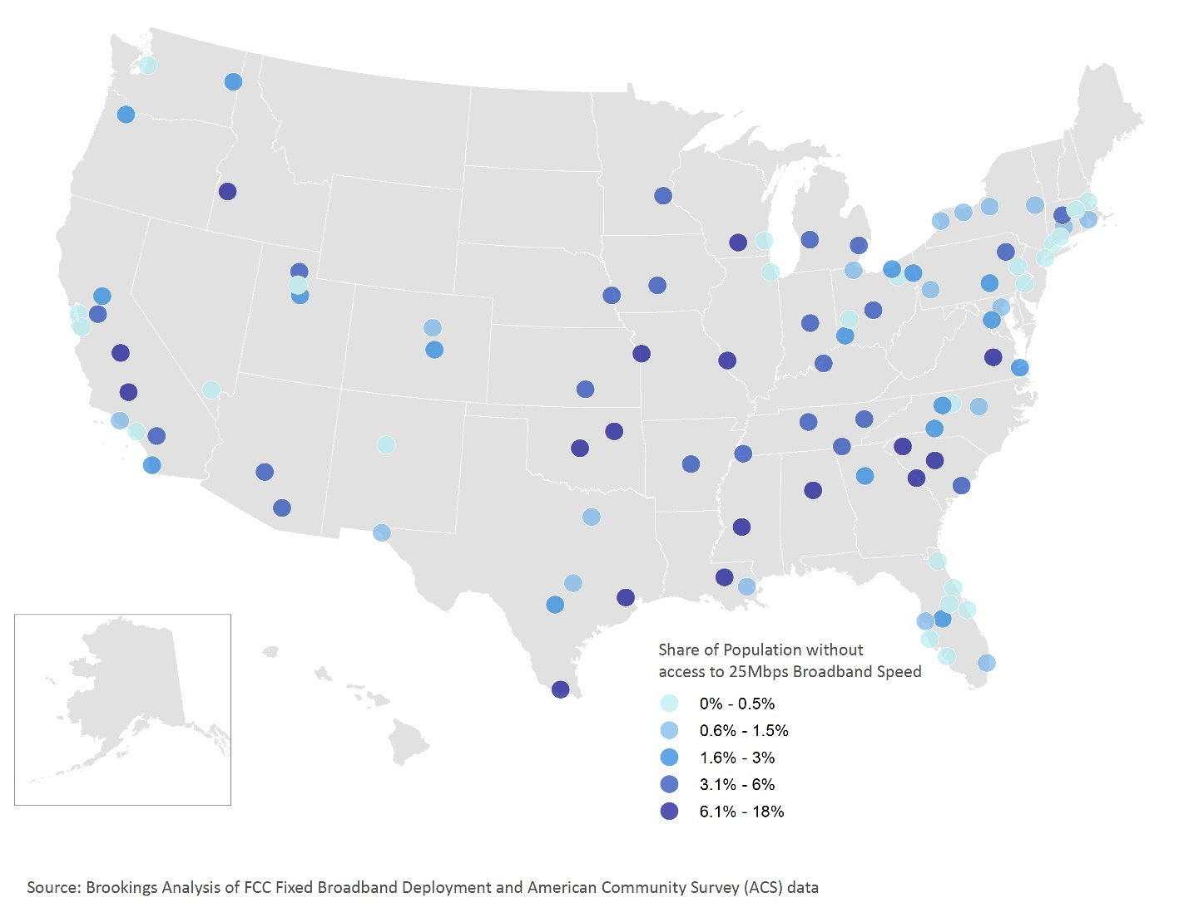

*Source: Brookings Institution analysis of 2011-2015 American Community Survey and FCC data.*

At the other end of the spectrum, more than a dozen regions experienced gaps in coverage that outstripped the national average. The availability gap reached 18 percent in the Tulsa, Okla. region and hit double digits in another six metro areas (Table 2). By and large, the metro areas with the biggest shortfalls in broadband availability are located in the South, including Tulsa and Oklahoma City; Jackson, Miss.; and Augusta-Richmond County, Ga., and in agriculturally oriented regions in the West, like Fresno and Bakersfield in California.

For these regions, gaps in broadband availability translate into tens of thousands, and in some cases hundreds of thousands, of residents lacking high-speed wireline service in their neighborhoods. By far, Houston was home to the largest population with no broadband coverage in 2015, with almost half a million metro area residents living in neighborhoods without 25 Mbps broadband service.

**Table 2: Major metro areas that have the largest share of residents without 25 Mbps broadband service availability**

|  |  |  |  |  |  |
| --- | --- | --- | --- | --- | --- |
|  | **Residents without 25 Mbps service in their neighborhoods** | |  | **Average population density of unserved tracts** | **Percent of unserved neighborhoods located in suburbs** |
|  | **Share** | **Number** |  | **Pop./sq mi.** |  |
| Tulsa, OK | 18% | 169,510 |  | 104 | 100% |
| Jackson, MS | 16% | 92,864 |  | 134 | 100% |
| Oklahoma City, OK | 12% | 156,399 |  | 546 | 76% |
| Augusta-Richmond County, GA-SC | 12% | 67,966 |  | 213 | 86% |
| Fresno, CA | 11% | 101,999 |  | 392 | 100% |
| Birmingham-Hoover, AL | 11% | 119,557 |  | 240 | 96% |
| Columbia, SC | 10% | 76,823 |  | 45 | 100% |
| Greenville-Anderson-Mauldin, SC | 9% | 80,760 |  | 428 | 100% |
| Kansas City, MO-KS | 8% | 161,466 |  | 48 | 93% |
| Baton Rouge, LA | 8% | 64,221 |  | 467 | 92% |
| Madison, WI | 8% | 47,682 |  | 36 | 100% |
| Boise City, ID | 8% | 49,443 |  | 51 | 100% |
| Houston-The Woodlands-Sugar Land, TX | 8% | 478,781 |  | 5,091 | 60% |
| Richmond, VA | 7% | 89,242 |  | 321 | 100% |
| Bakersfield, CA | 7% | 57,034 |  | 895 | 100% |

*Source: Brookings Institution analysis of 2011-2015 American Community Survey and FCC data.*

As with coverage disparities between rural and urban America, gaps in broadband availability across and within metro areas often reflect differences in density. In the nation’s 100 largest metro areas, the average population density for neighborhoods *with* 25 Mbps service was 7,731 residents per square mile. For tracts *without* broadband availability, the average population density was six times lower (1,339). Unserved neighborhoods tend to be even more sparsely populated than average in the metro areas posting the largest overall coverage gaps, with as few as 36 people per square mile in the unserved neighborhoods of Madison, Wis.

Table 2 also shows, perhaps not surprisingly, that neighborhoods without broadband service in the nation’s largest metro areas are overwhelmingly suburban. Among the 90 metro areas that have a gap in 25 Mbps broadband service coverage, in all but five of those regions that gap was driven mostly (in 24 regions) or entirely (in 61 metro areas) by suburban neighborhoods.

Houston proves a bit of an exception among the metro areas listed in Table 2. Its availability gap is distributed more evenly between urban and suburban neighborhoods, and, in turn, the region’s unserved neighborhoods are much more densely populated than might be expected. However, if the bar for high-speed service is lowered from 25 Mbps to 10 Mbps, the picture improves dramatically for Houston: the region’s coverage gap shrinks to 1 percent and its rank drops from 13th to 16th among the nation’s 100 largest metro areas. However, because Houston is such a populous region, even a coverage gap of just 1 percent means that a significant number of residents—94,000—lacked high-speed wireline service as of December 2015.

Indeed, every major metro with a coverage gap sees that gap shrink to some degree using the 10 Mbps benchmark, and no major metro area registers a shortfall of more than 6 percent under that measure (Table 3).

**Table 3: Major metro areas that have the largest share of residents with no 10 Mbps broadband service in their neighborhoods**

|  |  |  |  |  |  |
| --- | --- | --- | --- | --- | --- |
|  | **Residents without 10 Mbps service in their neighborhoods** | |  | **Rank among top 100 metro areas** | |
|  | **Number** | **Share** |  | **10 Mbps** | **25 Mbps** |
| Richmond, VA | 71,454 | 6% |  | 1 | 14 |
| Augusta-Richmond County, GA-SC | 32,553 | 6% |  | 2 | 4 |
| Bakersfield, CA | 43,282 | 5% |  | 3 | 15 |
| Baton Rouge, LA | 40,453 | 5% |  | 4 | 10 |
| Fresno, CA | 44,968 | 5% |  | 5 | 5 |
| Tulsa, OK | 42,477 | 4% |  | 6 | 1 |
| Jackson, MS | 22,150 | 4% |  | 7 | 2 |
| Oklahoma City, OK | 41,767 | 3% |  | 8 | 3 |
| Wichita, KS | 19,020 | 3% |  | 9 | 22 |
| Boise City, ID | 16,297 | 3% |  | 10 | 12 |
| Memphis, TN-MS-AR | 32,564 | 2% |  | 11 | 23 |
| Greenville-Anderson-Mauldin, SC | 19,564 | 2% |  | 12 | 8 |
| Little Rock-North Little Rock-Conway, AR | 14,019 | 2% |  | 13 | 19 |
| Riverside-San Bernardino-Ontario, CA | 75,491 | 2% |  | 14 | 38 |
| Columbia, SC | 12,624 | 2% |  | 15 | 7 |

*Source: Brookings Institution analysis of 2011-2015 American Community Survey and FCC data.*

These service patterns within and across the nation’s largest metro areas show that, while broadband is not yet ubiquitous, providers of wireline infrastructure have succeeded in deploying it to the vast majority of residents in major metro areas. At the same time, the larger coverage gaps at 25 Mbps compared to 10 Mbps suggest that less dense, agriculturally oriented regions and farther-flung suburban neighborhoods may experience a lag in gaining service at faster speeds.

That is not to say that metropolitan America has entirely bridged the digital divide. “Laying the pipes” is a necessary step to ensuring residents can physically access the benefits of broadband service, but availability alone does not equal adoption—broadband subscriptions are equally important. Otherwise, a broadband connection with no subscription is simply an underused asset. The next two findings assess subscription patterns in neighborhoods across the country.

***Finding 3: Over 73 million people (23 percent of the nation’s population) live in neighborhoods where in-home broadband subscription rates fall below 40 percent.***

National statistics on the extent to which households are subscribing to broadband reveal a country undergoing an uneven transition to the digitally connected economy, and they illuminate a digital divide that splits along both geographic and economic lines.

Due to the structure of FCC subscription data, broadband speeds within this section are defined as 10 Mbps download and 1 Mbps upload.

In 2015, almost one in four people (a total of 73.5 million) in the United States lived in *low subscription*neighborhoods, where fewer than 40 percent of households subscribed to broadband. Such neighborhoods concentrate the digitally disconnected portions of the American population, leaving their residents at risk of missing the economic benefits of a high-speed internet connection. Especially concerning are the 17.7 million children under the age of 18 dwelling in these neighborhoods. Living without an in-home broadband connection is a challenge for children, as they may not be able to benefit from digital curricula or develop digital skills for the future workplace. But it is especially challenging for schools and school districts that serve clusters of non-subscribing households.

**Box 2: Digital distress among youth**

Broadband connectivity is important for the entire economy but especially so for the under-18 population. Digital curricula, including requirements to complete and submit homework online, are already a central component of primary and secondary schools’ educational strategy. Once students complete school, they’ll find a job market that increasingly requires digital skills to qualify for employment and to succeed on the job. Wireline broadband in the home fundamentally prepares youth for the digital present and future.

However, U.S. broadband performance leaves many youth digitally disconnected in their homes (Figure 6). It starts with a lack of availability: nearly 5 million children under the age of 18 live in neighborhoods where 25 Mbps broadband service is not available. The largest gaps are in rural America, where 2.8 million youth lack broadband in their neighborhoods, but 1 million suburban youth spread across metro areas like Atlanta, St. Louis, and Riverside, Calif. also live without broadband options.

Equally troubling are the 17.7 million children living in neighborhoods with low subscription rates, meaning that fewer than 40 percent of all households in those neighborhoods subscribe to a wired connection. In rural areas, two-thirds of all children live in low subscription neighborhoods, demonstrating just how pervasive the broadband disconnect is in these corners of the country. There are also over 7,000 neighborhoods between large metro cities and suburbs that fall into the low subscription category, housing almost 7 million children. These neighborhoods include 1,800 where subscription rates fall below 20 percent.

**Figure 6: Population under 18 with no broadband availability or living in low subscription neighborhoods**

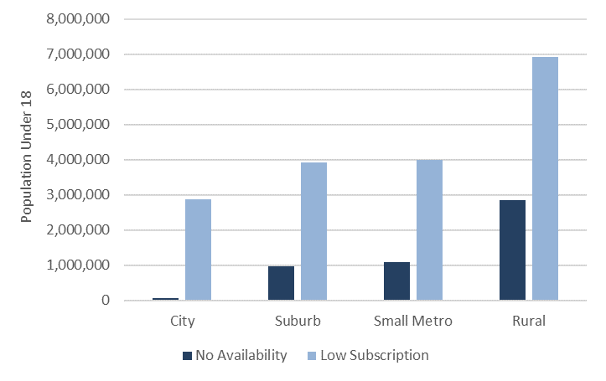

*Source: Brookings Institution analysis of 2011-2015 American Community Survey and FCC data.*

Such broadband disconnection among the country’s youth is a significant social equity and economic competitiveness challenge. A child cannot choose whether to live in a house with a wired broadband subscription—nor one with a wireless data plan—but it will shape his or her economic future. Likewise, in school districts where many households do not have broadband, educational capabilities may be limited for all students. Leaving children unprepared for the jobs of today and tomorrow stands not only to weaken their access to economic opportunity, but it also could limit the next generation of entrepreneurs and skilled workers necessary to power future industry.

Most Americans—185.7 million people or 59 percent of the nation—experienced somewhat better connectivity in *moderate subscription* neighborhoods, i.e., census tracts with subscription rates between 40 and 80 percent. However, these neighborhoods still fall short of a national goal of nearing 100 percent subscription. In practice, only a modest share of the population lives in neighborhoods that either come close to or have already achieved that goal. *High subscription* neighborhoods, where at least 80 percent of households subscribe to high-speed broadband, were home to just 18 percent of the nation—or 57.1 million people—in 2015.

Looking at these three neighborhood-level subscription categories across different kinds of communities brings to light clear geographic differences (Figure 7), and those differences are distinct from availability performance. Suburban neighborhoods in the 100 largest metro areas achieve the country’s highest broadband subscription rates, with only 11 percent of suburban residents living in low subscription neighborhoods and over a quarter of residents living in high subscription neighborhoods. While large city neighborhoods have fewer availability gaps than suburban neighborhoods, they are home to higher shares of residents living in low subscription neighborhoods and lower shares in high subscription tracts compared to the suburbs. Finally, small metro and rural neighborhoods adopt broadband at much lower rates than large metro neighborhoods. The 65 percent of rural residents living in low subscription neighborhoods is especially troubling since it far exceeds the availability gap in those places.

**Figure 7: Share of the population by neighborhood broadband subscription category and geographic type**

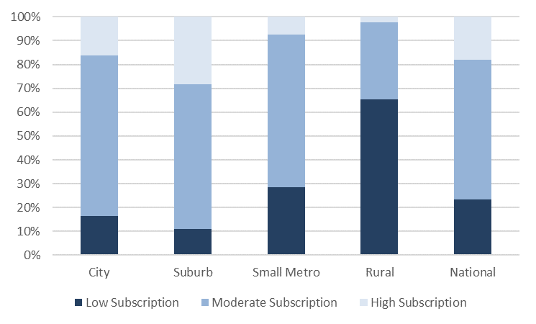

*Source: Brookings Institution analysis of 2011-2015 American Community Survey and FCC data.*

Parsing subscription levels by income reveals similar discrepancies (Figure 8). Low-income neighborhoods (i.e., census tracts with median incomes below 80 percent of the area median income, or AMI) register the weakest subscription rates, both in terms of how many people live in low subscription neighborhoods (37 percent) and how few live in high subscription neighborhoods (4 percent). It is the opposite for high-income neighborhoods (i.e., census tracts with median incomes at least 150 percent above the AMI), where just 3 percent of residents live in low subscription neighborhoods and more than half live in high subscription places (53 percent). Perhaps not surprisingly, subscription levels in middle-income neighborhoods, where most Americans live (56 percent), align closely with national averages. Taken as a whole, the discrepancies in neighborhood broadband subscription levels across income categories suggest that those being left behind by the transition to the digitally connected economy are also those who were already struggling economically.

**Figure 8: Share of the population by neighborhood broadband subscription category and income**

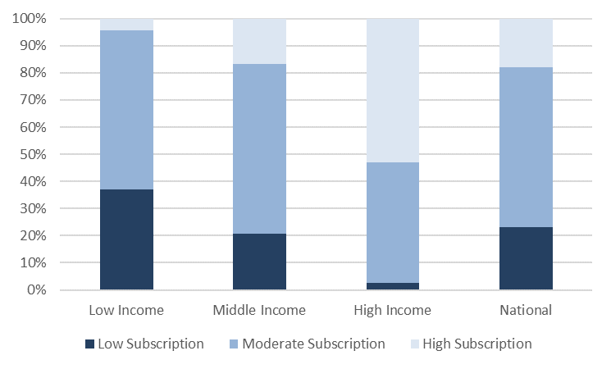

*Source: Brookings Institution analysis of 2011-2015 American Community Survey and FCC data.*

Yet, geography and income are just two components that might affect broadband subscription. Using national census data at the neighborhood scale, it is possible to control for an even wider range of demographic and economic characteristics to test which have the strongest relationships with neighborhood subscription levels. (To see a detailed explanation and analysis of the regression model, see Appendix B.)

The results in many ways confirm past academic research but also raise important questions. Neighborhoods with less-educated, lower-income, and older residents all are associated with lower subscription rates—a clear confirmation of past research and an important signal for policymakers. Race tended to have much smaller and sometimes insignificant effects, however, a finding that deviates from survey results and individual-level models that find significant subscription gaps by race. In this case, further research should investigate racial components and how neighborhood effects may impact broadband subscription. Interestingly, larger shares of foreign-born residents were associated with higher subscription levels. This is another area ideally suited for more research.

Overall, these aggregate and modeled results suggest that the digital divide is now primarily one of subscription, not availability. The next finding investigates how those subscription gaps deviate between and within specific metropolitan areas.

***Finding 4: Nearly every large metro area includes neighborhoods with subscription rates below 40 percent, but the gaps are largest in less dense regions.***

While residents in large metropolitan areas subscribe to wireline broadband at higher rates than their small metropolitan and rural peers, there is considerable variation between and within these places. Addressing subscription gaps within the 100 largest metro areas, which represent 67 percent of the national population and 74 percent of GDP, is a critical step to get more Americans online and engaged in the digital economy.

Policymakers’ chief concern should be addressing gaps in low subscription neighborhoods where fewer than 40 percent of households have an in-home subscription. As Map 2 shows, there are 23 metro areas where the share of residents living in such neighborhoods exceeded the national average of 23.2 percent in 2015. Most of these low-performing metro areas are in the South and West, stretching from the Carolinas to California, and are home to fewer than 1 million residents.[57] McAllen, Texas stands out in this regard, with 75 percent of its residents living in low subscription neighborhoods. In Albuquerque, N.M. and Boise, Idaho, over half the population lives in such neighborhoods.

**Map 2: Share of population living in low subscription neighborhoods, 100 largest metropolitan areas**

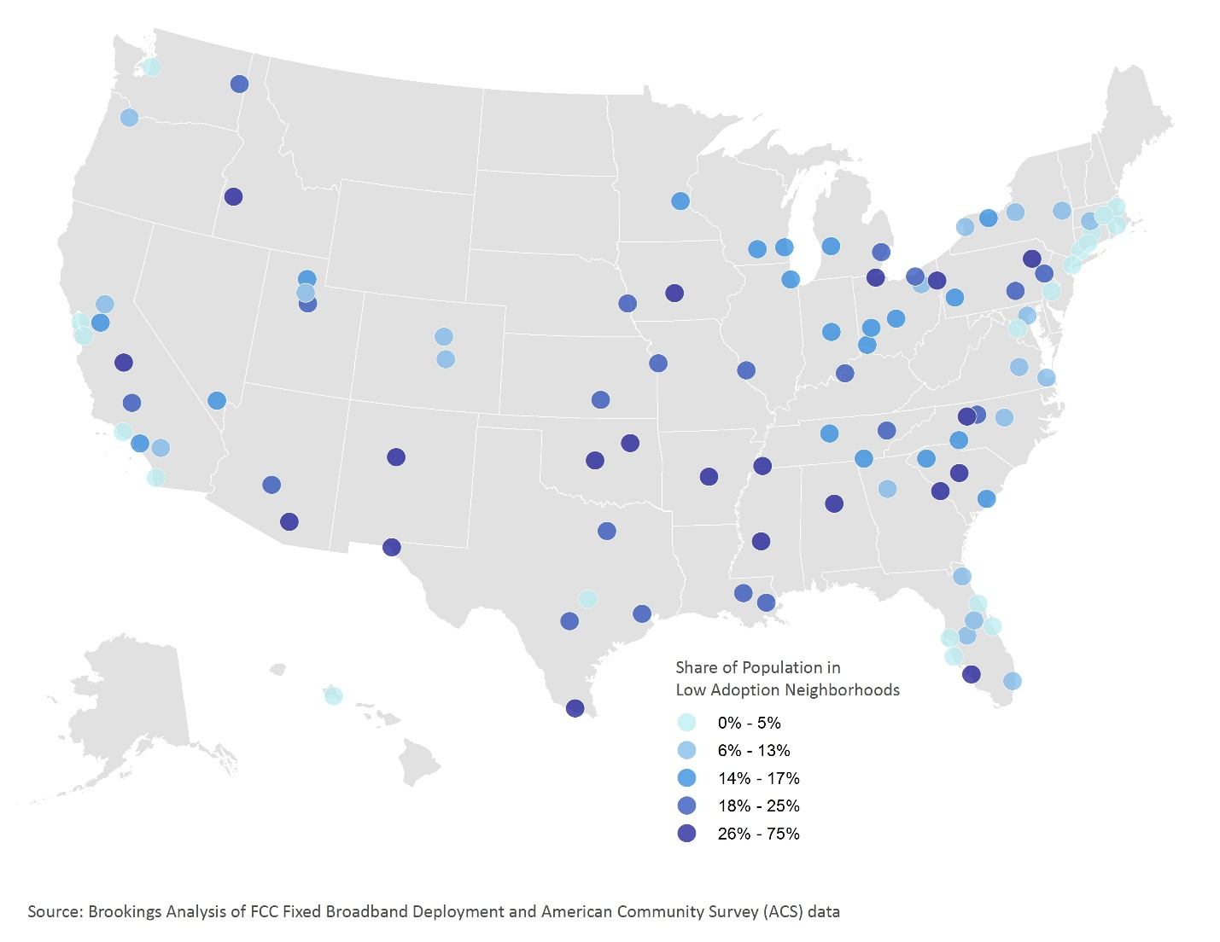

*Source: Brookings Institution analysis of 2011-2015 American Community Survey and FCC data.*

Metro areas that register the largest absolute number of residents in low subscription neighborhoods tend to be regions that are more populous overall, including the four largest metro areas in the nation: Los Angeles, Houston, Dallas, and Chicago. While each metro area in Table 4 is below average in terms of the *share* of people living in low subscription neighborhoods, collectively this group comprises 5.7 million people. To put that number in perspective, it is more than the entire population of metropolitan Atlanta. For these large metro areas, getting more people online within low subscription neighborhoods is vital to boosting metropolitan-wide subscription rates.

**Table 4: Top 10 metropolitan areas by total population living in low subscription neighborhoods**



*Source: Brookings Institution analysis of 2011-2015 American Community Survey and FCC data.*

At the same time, there are many metro areas with very few residents living in low subscription neighborhoods. In six, fewer than 1 percent of residents lived in low subscription neighborhoods in 2015. In Bridgeport, Conn.; Providence, R.I.; Boston; and Palm Bay, Deltona, and North Port, Fla., fewer than 10 percent did. The higher rates of subscription in these regions may reflect market dynamics (e.g., resident preferences or competitive pricing) or targeted policies that encourage or enable greater broadband uptake. These are topics beyond the scope of this paper, but worthy of additional and perhaps local research.

At the other end of the spectrum, 41 of the nation’s 100 largest metro areas had a higher-than-average share of residents living in high subscription neighborhoods. Washington performed the best by this measure, with over 61 percent of people living in high subscription neighborhoods and just 2.5 percent living in low subscription tracts. In New York, Philadelphia, San Diego, and Tampa, Fla.—each large population centers with more than 2 million residents—the share of residents in high subscription neighborhoods outstrips the proportion in low subscription tracts.

Several other metro areas, including Minneapolis, Salt Lake City, and Portland, Ore., lagged behind the national average for the share of residents living in high subscription neighborhoods; for each, fewer than 5 percent of residents did in 2015. But these low shares were not the result of having high shares of residents in low subscription places. Instead, over three-quarters of the population in these regions lived in moderate subscription neighborhoods.

In addition to each metro area’s baseline, it is also possible to compare broadband subscription between cities and suburbs. At the aggregate level, greater shares of the population in suburbs live in high subscription tracts and smaller shares live in low subscription tracts than their city peers. But disaggregating that data shows extreme differences from one metro area to the next.

Figure 9 charts the difference between the share of city and suburban residents living in low subscription tracts. The bars’ overall curvature confirms how much neighborhood-level subscription patterns differ between metro areas. Furthest to the left, in suburbs in McAllen, Texas; Boise, Idaho; Albuquerque, N.M.; and Cape Coral-Fort Myers, Fla., significantly higher shares of the population live in low subscription tracts relative to the central cities. Conversely, much higher rates of city residents in metropolitan Cleveland, Detroit, Baltimore, and Provo, Utah live in low subscription tracts. Overall, 59 of the 100 metro areas show absolute differences of at least 10 percentage points between their cities and suburbs, whether positive or negative on this scale. And while not charted here, the variation is similar when comparing city and suburban populations living in high subscription tracts.

**Figure 9: City population share versus suburban population share living in low subscription neighborhoods, 100 largest metropolitan areas**

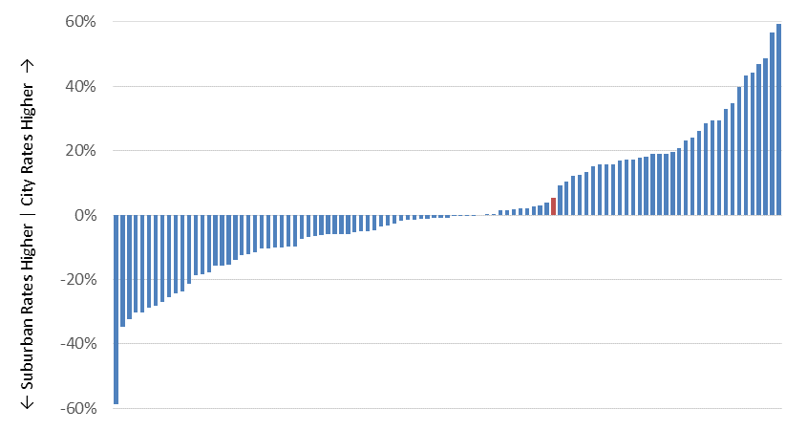

*Note: Red bar indicates average city/suburb split for the 100 metropolitan areas.*

*Source: Brookings Institution analysis of 2011-2015 American Community Survey and FCC data.*

Diving into two specific markets helps one visualize different local subscription patterns (Map 3). San Antonio and San Diego are both Sunbelt metro areas with over 2 million total residents and a heavy military presence. The two regions also have comparable levels of availability: broadband serves 98 percent of the total population in both metro areas, with only minor gaps in their suburbs and full coverage in their core city. Yet their neighborhood subscription patterns vary significantly. San Diego has only small pockets of low subscription, mostly located in the sparsely populated east. High subscription tracts are much more prevalent, with 43 percent of people living in such neighborhoods. Conversely, a quarter of San Antonio’s population lives in low subscription tracts in large swaths of the city and suburbs. High subscription tracts appear almost exclusively in the northern suburbs and in isolated places within the central city.

**Map 3: Broadband subscription categories by census tract, San Diego and San Antonio**

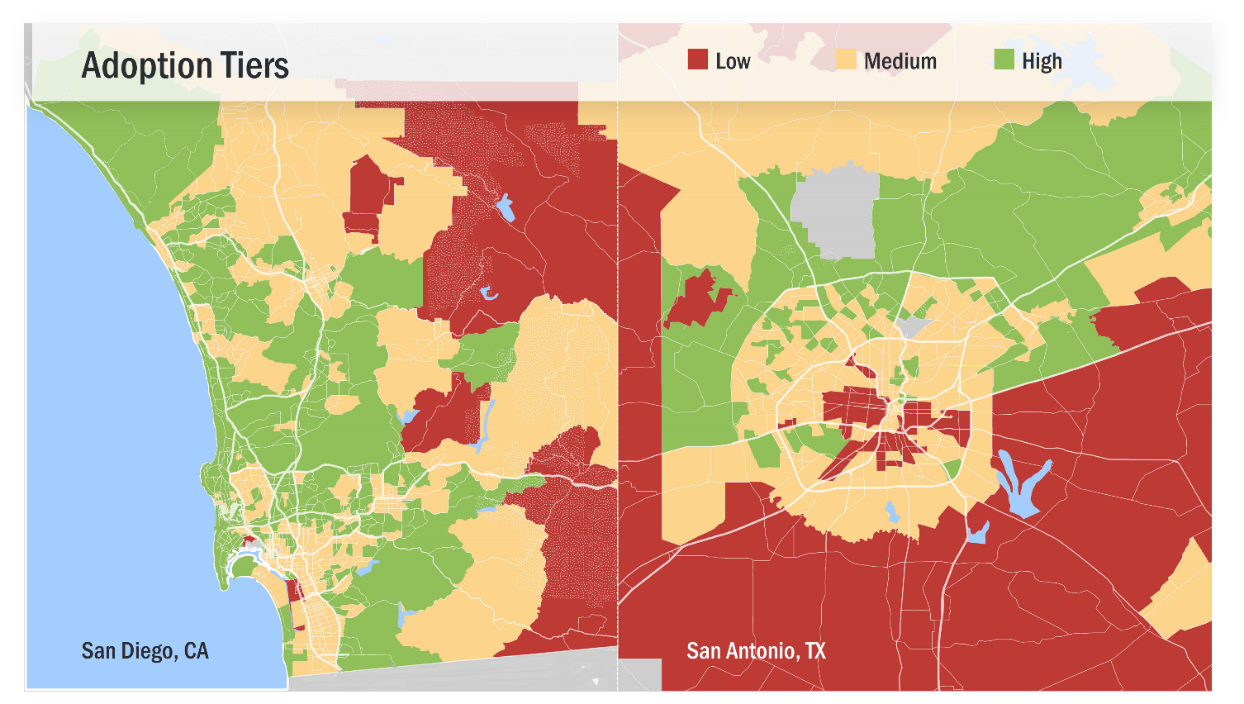

*Source: Brookings Institution analysis of 2011-2015 American Community Survey and FCC data.*

While a great amount of variation in subscription levels exists both within and across the 100 largest metro areas, the pattern uniting each metro area is the presence of digital disconnect. In fact, low subscription tracts exist in the surrounding suburbs of all 100 metro areas and in the cities of all but six metro areas: Allentown, Pa.; Deltona, North Port, and Palm Bay, Fla.; Providence, R.I.; and San Jose, Calif. In other words, the digital divide is pervasive.

***Finding 5: A combined index of broadband availability and subscription demonstrates the overall strength of metro areas in Florida, the Northeast, and the Pacific Coast and lagging performance in the Southeast and Great Plains.***

Broadband availability and subscription both are integral to unlocking the economic benefits of a high-speed internet connection. While limited deployments are a pressing challenge in some metropolitan areas, other places struggle with getting residents subscribed. This section introduces a combined index to simultaneously assess both broadband availability and subscription in the country’s largest metropolitan areas. The index uses percentile standard scores to measure the share of all residents where broadband is available and the distribution of broadband subscription across the FCC’s categorical data.[58] These two standard scores are then added to rank the best and worst overall metropolitan performers (Appendix C includes all rankings).

Perhaps not surprisingly given the strong performance of many Florida metro areas throughout this analysis, those areas dominate the highest rankings produced by this combined measure (Map 4 and Table 5). In places like Palm Bay and Deltona, not only is complete service coverage available to residents, but higher-than-average shares of the populations live in high subscription neighborhoods and virtually none live in low subscription areas. In addition to the four Florida metro areas that rank in the top 10, Orlando ranks 12th out of 100 and Miami and Jacksonville are just outside the top 20. Just as importantly, none of the state’s large metro areas rank in the bottom half.

The Northeast exhibits similar patterns, with regions like New York and Boston offering 25 Mbps service availability to practically all of their millions of residents, the majority of whom live in high subscription neighborhoods. Philadelphia and Washington generate nearly the same high scores. Many Pacific Coast large metro areas—including San Jose, San Francisco, and San Diego—also rank in the top 20. Austin, Texas is the only top 20 metro area not on either coast.

**Map 4: Combined availability/subscription standard score rankings, 100 largest metropolitan areas**

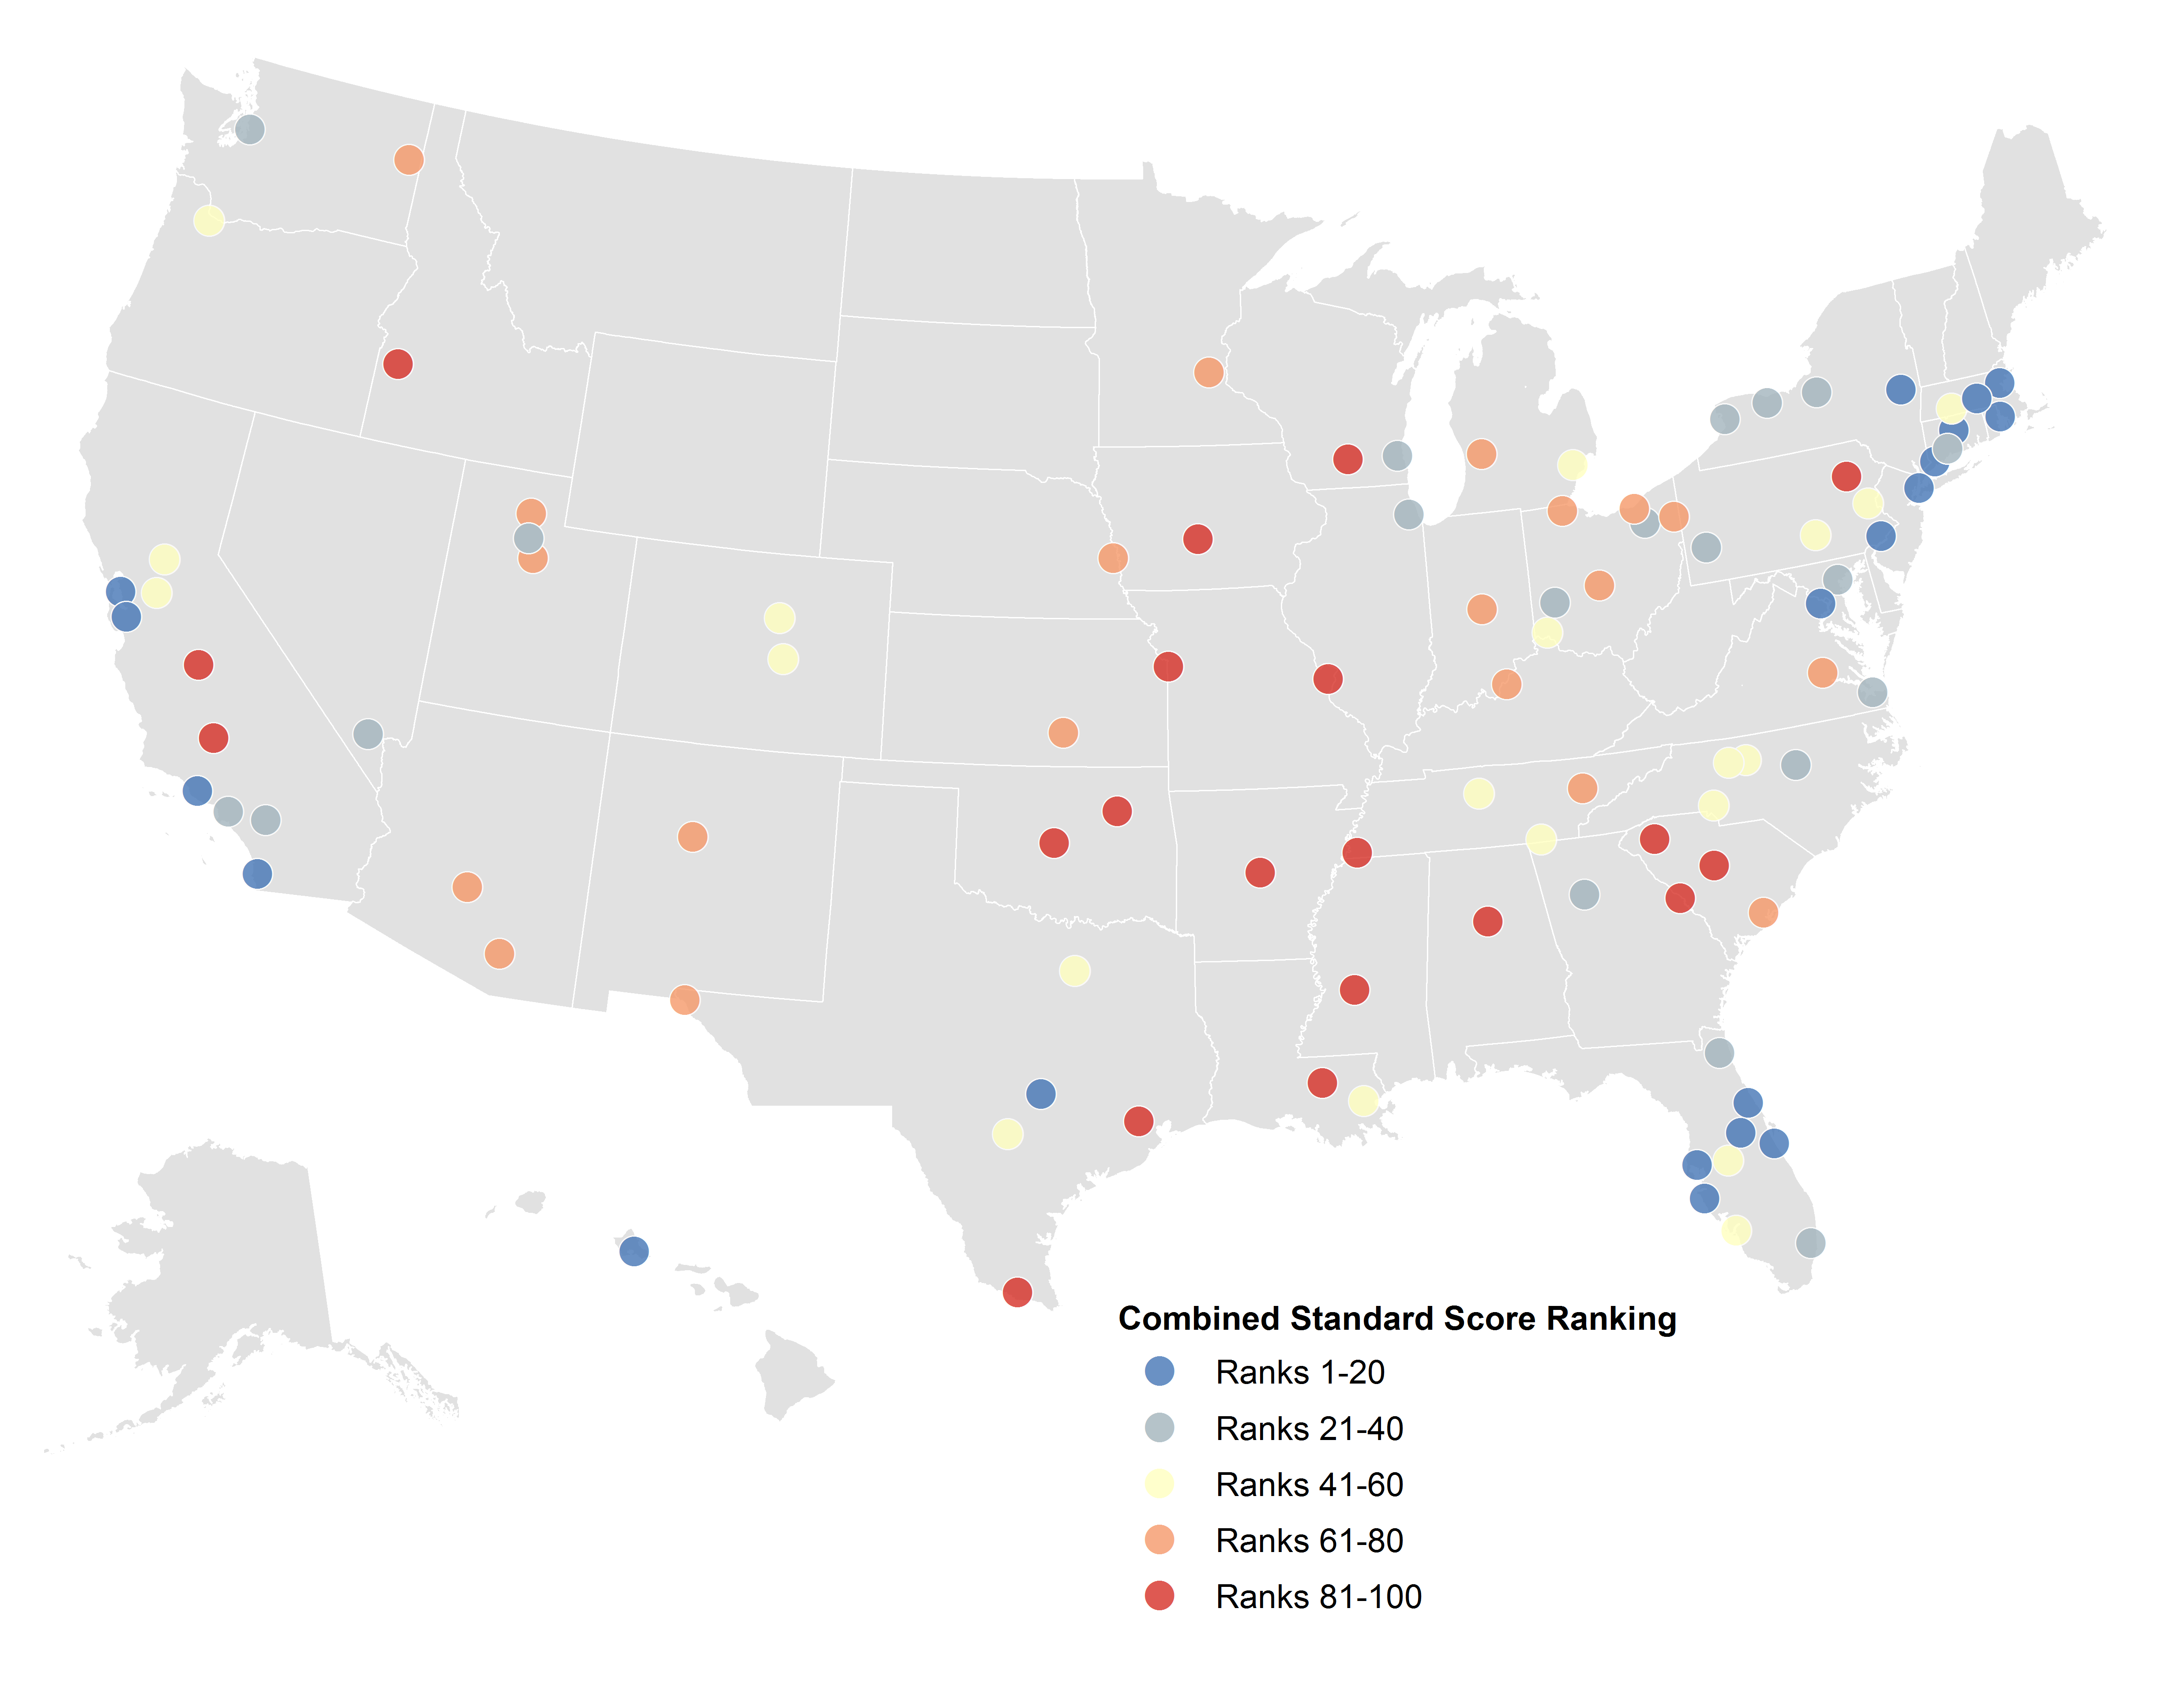

*Source: Brookings Institution analysis of 2011-2015 American Community Survey and FCC data.*

In contrast, Southeastern metro areas outside Florida and many Great Plains metro areas exhibit lagging performance on both availability and subscription metrics relative to their peers. The large metro areas in states running from Texas to South Carolina and north along the Mississippi River represent two discernible bands of bottom-20 places. Many of these metro areas—including Tulsa, Okla.; Jackson, Miss.; and Columbia, S.C.—rank among the lowest for availability rates and register some of the highest shares of residents living in low subscription neighborhoods. But a number of the metro areas in this bottom quintile struggle more with availability than subscription, including Houston, St. Louis, and Madison, Wis.

**Table 5: Top 10 and bottom 10 metropolitan areas by combined availability/subscription standard score** 

*Source: Brookings Institution analysis of 2011-2015 American Community Survey and FCC data.*

It is important to note these rankings will continue to change over time as broadband deployment and consumer choices evolve, both of which can change quickly. For instance, new broadband deployments would improve statistics in some markets. Also, people may have subscribed to high-speed service after the time period our data capture, which would shift neighborhoods to higher subscription categories.

Regardless of change over time, these rankings amplify the need to assess where strengths and challenges exist *within* metropolitan areas. Based on the first two findings, metro areas scoring lower on broadband availability likely need to look to their lower-density neighborhoods to boost deployment and service quality. Metro areas with lower scores based on their broadband subscription rates will likely need to focus on lower-income, less-educated neighborhoods where residents tend to subscribe at lower rates. While these rankings provide metropolitan benchmarks, effectively targeting solutions will require neighborhood-level maps.

**Box 3: The historical role of government in addressing the digital divide**

While the digital divide persists across both the availability and adoption dimensions, governments and private firms continue to evolve in how they address these inequities. When discussing ways in which policymakers and practitioners can act to help close deployment and subscription gaps, it is important to understand what efforts are already underway.

Federally, there is a long tradition of direct policy interventions regarding broadband availability and adoption (Figure 10). With the passage of the Telecommunications Act in 1996, Congress built the foundation for modern broadband law, and in the 2000s it acted to improve data policies, tax approaches, and to authorize targeted investments. However, Congress has so far focused almost exclusively on deployment. The Department of Agriculture also focuses on availability (versus adoption) by financing rural broadband infrastructure through its longstanding Broadband Loan and Community Connect programs.[59] The Department of Housing and Urban Development recently began to build out deployment and adoption programs such as ConnectHome, although the future of those programs is uncertain. Similar funding concerns apply to the Department of Commerce’s National Telecommunications and Information Administration, which runs the nearly complete Broadband Technology Opportunities Program and did run the now-closed State Broadband Initiative. Together, those programs represent the largest federal broadband adoption programs to date.

**Figure 10: Federal broadband law and agency programs, 1982 to present**

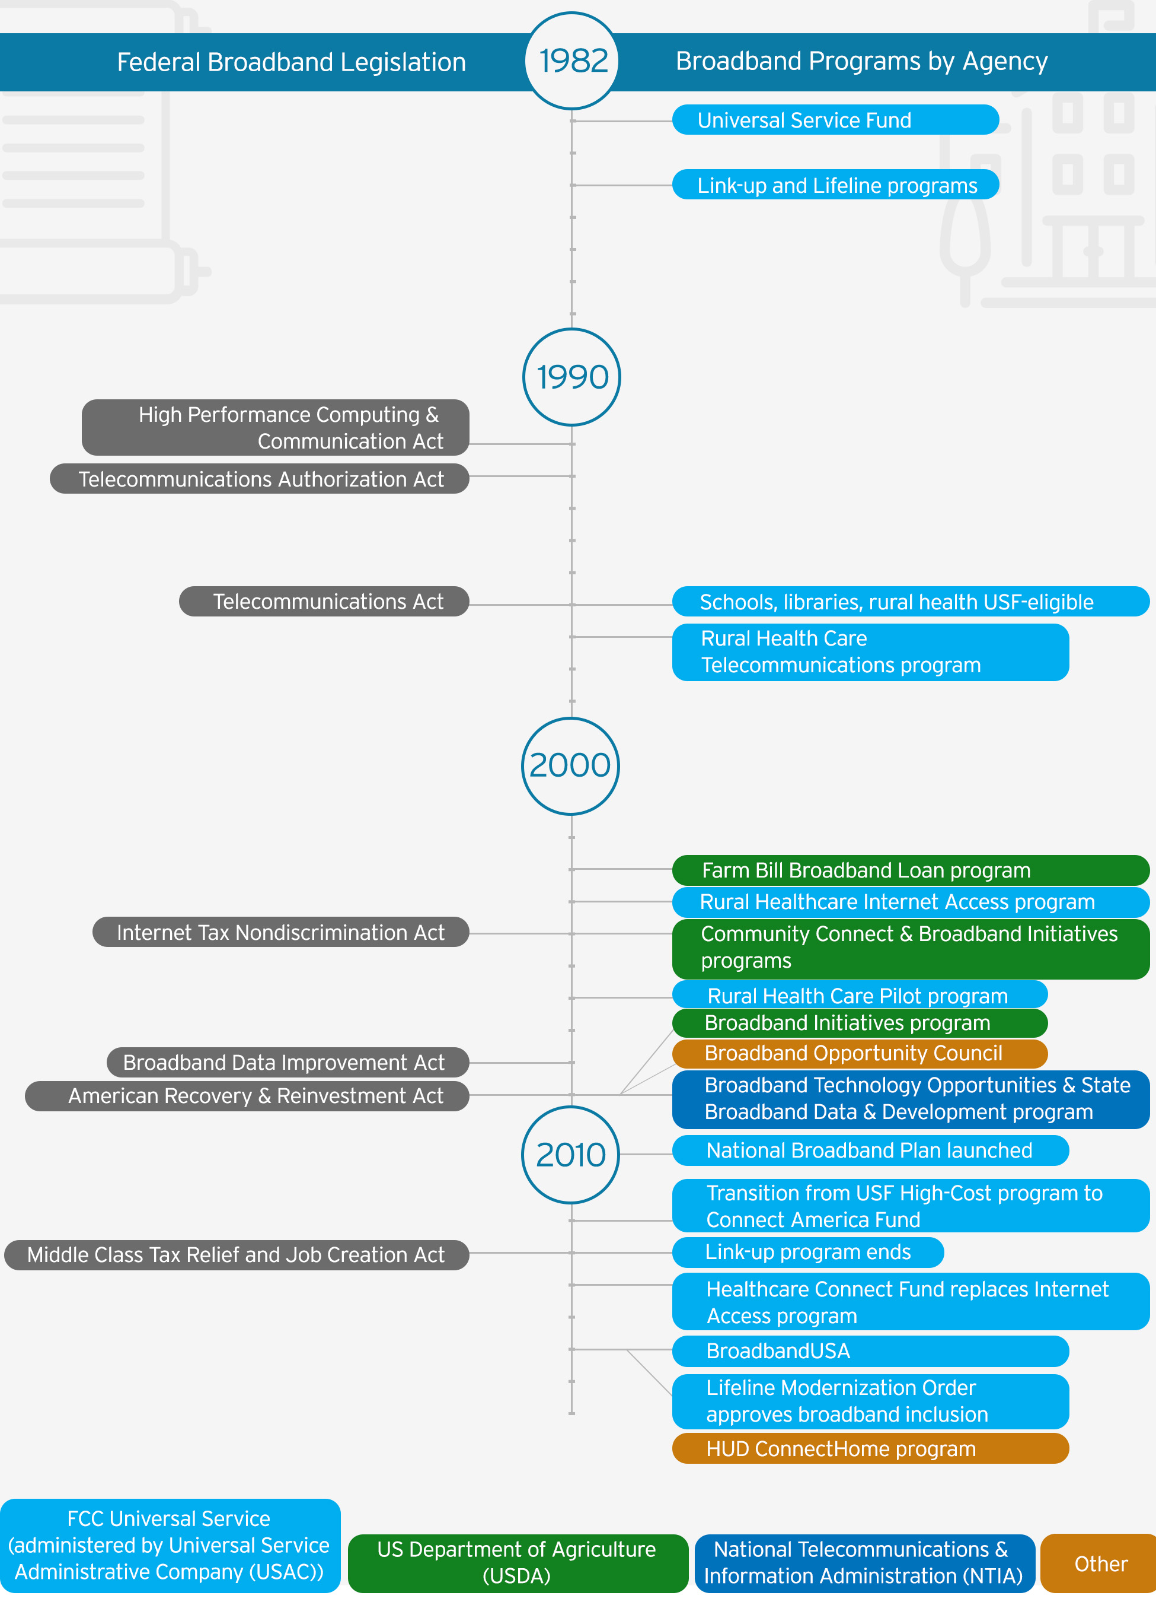

*Source: Brookings Institution.*

The FCC has the largest sustained presence on these issues among federal agencies, owing to the sizable and secure funding streams for its availability and adoption programs. Using fees collected from telecommunications providers, the Universal Service Fund directs billions each year to rural deployments (through the Connect America Fund), connections for schools and libraries (E-rate), rural health care facilities, and low-income broadband adoption support (Lifeline).

Flexibilities in federal law give states and localities latitude in how they approach broadband deployment and adoption. In some states, such as Kentucky, public construction efforts are underway.[60] In others, like Tennessee, laws explicitly forbid local governments from building their own public networks—and those laws were reinforced by a federal judicial decision.[61] There is a similar disparity between how localities approach cable franchise agreements, right-of-way access, and pole attachment policies.[62]

Internet service providers (ISPs) also play an important role. As the primary investor in and operator of the country’s telecommunications networks, these private firms will continue to be the primary driver of where broadband is available, at what speeds, and for what price. But many of the largest providers also offer—independent of the federal Lifeline program—discounted rates to low-income households. Many also engage in civic philanthropy through such initiatives as equipment donations to local school districts. While there are certainly adversarial components to ISPs’ relationships with governments, there are also many areas where goals and objectives align.

Moving forward, governments will need to ensure that broadband deployment and adoption policies continue to evolve. One step would be the promotion of higher bandwidths to match greater hardware-processing capacity. New innovations like immersive online courses, virtual reality gaming, and real-time property management will all require gigabit-level speeds in the home.[63] And as more daily activity shifts to digital platforms, promoting greater broadband adoption will only grow in importance.

**Implications**

Internet use inside the home is a fundamental component of the modern American economy, and that is especially true inside people’s homes. Students of all ages complete their homework online and stream videos to sharpen their skills. Jobseekers scan for new openings and network with colleagues. People of all ages use the internet to shop, watch television, play games, and talk face-to-face with family and friends. The internet also allows governments at all levels to find efficiencies and cost savings in their service provision, and these improvements stand to be particularly important for low-income residents. As dozens of mayors and city leaders recently wrote to the FCC, “Getting more low-income households online will help modernize delivery of public services—facilitating more responsive and effective governance while lowering overheads for local governments. E-government delivery also saves the public the expense of visiting government offices in person—a particular concern for low-income households.”[64]

In-home broadband makes all this possible. Unfortunately, many of the nation’s residents do not yet fully participate in the broadband economy.

In some parts of the country, availability is the chief issue. Over 22 million people live in neighborhoods that lack in-home broadband service at speeds of 25 Mbps or greater. Rural America represents over half of this group, confirming the difficulties of delivering high-speed service in low-density settings. Yet many large metro area neighborhoods also fail to connect a significant number of their residents to broadband service, including over 100,000 in Houston; Tulsa, Okla.; and Fresno, Calif. Even in the nation’s largest regional economies where 25 Mbps is widely available, few communities now offer a broadband platform built for the digital future: current gigabit-speed connections—which will be instrumental to growing, attracting, and sustaining data-hungry industries and occupations—reach only 5.7 percent of residents in the 100 largest metro areas.[65]

As formidable a hurdle as those availability gaps are for enhancing digital inclusion, particularly in rural America, for the 93 percent of the nation’s population where high-speed wireline service is available, it is broadband adoption that represents the primary hurdle to achieving full participation in the digital economy. The residents most likely to be left out—like the 73 million people living in low subscription neighborhoods—tend to be older, have lower incomes, and lower levels of education. These residents can be found in urban, suburban, and small metropolitan communities alike. But by far, subscription rates remain lowest in rural America, where adoption challenges (almost two-thirds of residents live in low subscription neighborhoods) are compounded by the high costs of addressing gaps across far-flung, low-density communities.

While gaps in availability have traditionally dominated the debate about digital equity, this analysis reveals the extent to which adoption, or lack thereof, has come to define America’s digital divide. As long as these twin gaps exist, the digital divide will hold back the national economy and limit economic opportunity in specific neighborhoods.

Assembling the right array of policy and programmatic interventions to address these availability and adoption challenges will require both an understanding of the diversity of starting points across different kinds of neighborhoods and communities—as evidenced by this analysis—and a forward-looking perspective on the role of evolving technology. It will also require the alignment of multiple efforts, bringing together a balanced framework of federalist public policies and collaborative partnerships between the private, public, and civic sectors.

As broadband’s presence within the American economy continues to mature, now is an opportune time to reconsider both national and local policy frameworks. The following section considers the role that federal actors do and should play in advancing both availability and adoption goals, and the next section turns to the role of local and regional stakeholders.

***The federal role: Balancing availability and adoption goals to bridge the digital divide***

Recognizing the fragmented landscape that governs broadband deployment, federal policy has long focused overwhelmingly on solving the collective action challenges inherent in increasing availability. Yet federal policy continues to largely overlook adoption. How the FCC handles Section 706 of the 1996 Telecommunications Act is emblematic of this tension: the law mandates that the FCC review advanced telecommunications deployment based on population, but it is on a voluntary basis that the agency monitors adoption.[66]

To some extent this arms-length approach stems from the complex array of factors—from pricing and marketing down to consumer choice and digital literacy—that shapes subscription levels. At the same time, the sheer scale of non-subscribed broadband households is difficult to ignore, and the fact that every community is affected—from New York City to rural Wyoming—generates political resonance and suggests the need for more targeted federal policy attention. There are clear opportunities to move adoption issues to the forefront of national policy, but current and past efforts have been patchwork.[67] Simply put, formal policy must move beyond volunteerism.

Moving forward, there are a number of ways—through funding, regulation, research, and technical assistance—that federal actors can continue to advance gains in availability while at the same time elevating their focus and commitment to reducing adoption barriers.

***Adopt policies to reduce deployment costs*.** Today, high-speed wireline service remains the most dependable way to get people connected to the digital economy. For the foreseeable future, then, it will still be vital to get more Americans subscribed to in-home broadband connections. To do so in an era of limited resources, Congress and executive agencies should give immediate attention to reducing deployment costs. One promising way to do so—if politics and industry can align on implementation—is through “dig once” policies, which allow for installing conduit or fiber optic cables during any right-of-way construction project (e.g., road construction).[68] Similar debates and alignment will need to take place regarding pole attachments and the potential for “one touch make ready” policies, which simplify the steps needed to create a new attachment on poles that may already be in use by other telecommunications or cable providers. For example, a one touch make ready policy might direct pole users to come together and select a common contractor for adjusting attachments as needed, rather than sending separate crews for each provider.[69]

***Consider the role of evolving wireless technology and business practices*.** Congress and the FCC must continue to craft policy and market interventions for the 12.7 million rural residents without broadband service, including many residents on tribal lands. The Connect America Fund will continue to make vital investments to advance availability for these households, but leaders should both consider the potential for future satellite technology to reduce public investment needs and actively review whether the quality of current Connect America Fund wireline investments will meet rural recipients’ long-term needs.

At the same time, policy leaders should consider how the build-out of new wireless networks—including proposed fifth-generation standards (5G)—and unlimited data plans within current networks will impact unserved populations in both rural and metropolitan communities.

Through small cell technology, 5G promises to offer wireless service to large geographic areas at speeds significantly faster than current networks. 5G will still require a wired backbone to connect the small cell transmission points, but it could eliminate the need for wired connections to each home.[70] However, questions remain whether in-home consumers would make the switch, and dependability relative to current wired offerings will be a major sticking point. Given that state and local decisions will determine how such policies are rolled out and where small cell transmission points will be located, local political dynamics and competing agendas could conceivably stymie efforts to close the digital divide through 5G deployment. There is a real opportunity for federal policy to create consistent guidelines for local governments and private firms, but those must both protect digital equality and local governments’ independence.

Likewise, unlimited data plans using current 4G LTE networks already enable many individuals to access broadband speeds in neighborhoods underserved by wireline. However, these services will only unlock broad-based economic benefits if all individuals can afford the service and if they connect to more productive devices, specifically desktops and laptops. Since lower-income individuals own computing devices and subscribe to wireless data plans at lower rates, these service improvements will not necessarily reach the entire population. Congressional and agency officials should debate whether other complementary programs, including device or service vouchers, are worthwhile complements to service changes by private wireless service providers.

***Move beyond stopgaps and pilots to more sustained adoption-focused funding streams and programming***. Broadband Technology Opportunities Program (BTOP) grants from the National Telecommunications and Information Administration (NTIA) enabled recipients to support adoption via outreach and training, but that program was funded only temporarily under the American Recovery and Reinvestment Act of 2010.[71] The Obama administration’s ConnectHome initiative targeted adoption among low-income families with school-age children living in public housing, but the effort was only an unfunded pilot.[72] And, as noted above, the FCC and NTIA do not formalize adoption objectives within their strategic plans.[73] The only sustained direct support to individuals is the Lifeline program, which the FCC recently expanded to offer direct broadband pricing support.[74]

Moving forward, Congress must work with the FCC, the NTIA, and other relevant agencies to establish sustained adoption-focused programs. That should include targeted pricing support where possible, both for monthly service like the FCC Lifeline program and potential purchase credits for equipment. Ideally, targeting support to low-income families with school-age children could ensure those families bring the digital classroom home. Similarly important are sustained support for training programs and capacity support in low-adoption communities. While the Broadband Opportunity Council has ended, the Broadband Interagency Working Group now meets in its place, with the goal of improving coordination among federal partners and programs, reducing regulatory hurdles that impede deployment, and raising awareness of available federal resources at the community-level.[75] In addition, NTIA’s BroadbandUSA Connectivity Assessment Tool provides a set of tools, resources, and technical assistance to support communities as they work to advance local broadband availability and adoption policies. The evolution and sustainability of this resource is contingent on continued funding from the current administration.[76] The federal government can also help scale successful interventions by assembling and distributing local best practices, a recommendation echoed by the Information Technology and Innovation Foundation.[77] Regularly updating NTIA’s Adoption Toolkit, first published in 2013, is one possible approach, and one that would also require sustained funding.[78]

***Forge metropolitan/rural alliances on Capitol Hill***. Considering geographic differences and aggregate funding needs, Congress will likely need to strike a grand bargain between those representing more metropolitan constituents and those representing primarily rural areas. Since each group has clear needs, there is room for a balanced approach. In particular, there is an opportunity for legislators to reform current public revenue streams to simultaneously fund availability and adoption programs and remove those programs from annual appropriations’ fights.

***Leverage public data more effectively***. The federal government can do more around data. The geographic granularity of the FCC’s availability and adoption data is excellent. However, the use of quintiles to report wireline adoption levels limits accuracy of analysis. The FCC should have an open debate about publicly releasing granular wireline neighborhood-level adoption rates, allowing researchers controlled access, and producing companion adoption statistics within the “Measuring Broadband America” report series.[79] Adding pricing and speed information within the availability data would help researchers and consumers alike, although this step introduces complexities due to internet-service bundling.[80] In both cases, however, it is clear that local leaders could use more accurate broadband data to better target their policy interventions. Likewise, the continued emergence of wireless data subscriptions demands improved data releases and followup research. If wireless becomes a more preferred option for in-home data, the FCC and independent researchers will have performance data to understand why.[81]

***Support further research efforts, including around technology, competition, and ownership*.** Broadband is an essential service, but a relatively new technology. There are many opportunities for research to expand the public’s understanding of how the broadband marketplace works and what the federal role could and should be. Fully funding research efforts like the National Science Foundation’s Advanced Wireless Initiative will be key to ensuring the United States stays at the digital telecommunications forefront.[82]

Another debate that looms large in this arena is what role competition does or should play in the provision of in-home broadband, both in terms of investment needed for deployment and in reaching optimal price points. Likewise, the emergence of state laws to block public ownership of broadband networks merits further national research, especially if such state laws are found to block ownership schemes that could improve economic opportunity.

***The role of local stakeholders: Align data and programs to reflect local needs***

Neighborhood-level broadband indicators reveal clear performance differences within and between communities of all sizes. As such, no one community will require the same interventions to address its availability and adoption gaps. However, local stakeholders from the public, private, and civic sectors can use common approaches to geographically target and design interventions that leverage federal, state, and local resources and programs and reflect local conditions and needs.

***Communities should use the levers they control to influence broadband availability***. Franchise agreements are a traditional way to influence a cable company’s broadband deployments in a given jurisdiction, but there are many more options to improve infrastructure extent and quality. In states where the law does not preempt local authority, competitiveness levers include establishing public or cooperative broadband providers, streamlining permitting for new entrants, and constructing public conduit that is available to all providers (or incentivizing private operators to do the same). Urban communities big and small could use targeted subsidies to incentivize deployments in specific neighborhoods, with one idea being Gigabit Opportunity Zones introduced by FCC then-Commissioner Ajit Pai.[83] The major challenge around deployment will continue to be the natural tensions between the public sector, whose mission is to maximize public utility for all, and private broadband providers, who are responsible for delivering profit to their shareholders.

***Collect and reflect on data to inform local priorities***. National surveys of broadband availability and adoption do an excellent job conveying the full extent of broadband challenges, but they’re often too aggregated to help design specific policy reforms. Given that broadband adoption is ultimately a household-by-household decision, blanket policies may not maximize impact. Effectively addressing the digital divide requires that policymakers, service providers, and advocates understand how policies and resources “go to ground” at the local level, and align federal, state, and local interventions accordingly.

For instance, a number of issues, such as pricing, can influence in-home adoption rates. The Pew Research Center’s most recent home broadband report finds that cost—both in terms of a subscription and computing equipment—is the primary reason 43 percent of survey respondents did not adopt in-home broadband.[84] Stakeholder interviews by the Government Accountability Office (GAO) confirmed similar issues with affordability.[85] At an even more fundamental level, GAO interviews and NTIA research finds that many Americans continue to question the relevance of the internet or perceive it as unsafe.[86] Even for those with the financial means and understanding of broadband’s benefits, a lack of digital literacy may impede adoption.[87]

While neighborhood-level performance indicators like those in this paper are a first-order requirement to benchmark local need, to fully understand the factors underlying the outcomes presented here public officials should go a step further and survey their neighborhoods on local conditions and attitudes related to broadband. For example, the City of Seattle runs a technology access and adoption survey every four years under its Digital Equity Initiative; the survey includes both demographic details and specific broadband performance measures.[88] The Minnesota Office of Broadband Development puts out annual reports on the state’s availability and adoption progress.[89] Such surveys are especially important in rural communities, where bridging availability gaps may be expensive and should require clear articulation of bandwidth needs based on local economic activity.

***Collaborate to drive adoption improvements***. Addressing multiple adoption barriers at the same time is vital, but it will not be cheap. Educators in community centers of all kinds will need to teach skeptical households and those struggling with digital literacy. Equipment will need to be bought, both to outfit community centers and to directly support individuals. Likewise, fully funded marketing campaigns (described in more detail below) are critical to reach the right people in the right neighborhoods. Orchestrating these complementary but separate efforts will require management staff inside and outside government, who must be paid. Government can certainly play a role in all this, but efforts at this scale will also require coordination with the private sector and civic institutions that have much to gain. One successful model is DigitalC, a Cleveland civic organization that collaborates directly with public agencies and private firms to close the digital divide. For example, DigitalC worked alongside the Cuyahoga Metropolitan Housing Authority to bring broadband service, computing equipment, and training to public housing units and their residents.[90]

***Develop campaigns tailored to local needs*.** Governmental, nonprofit, and academic research consistently finds public outreach and training programs to be an important strategy to boost broadband adoption. Doing so effectively will require a layered approach, including digital curricula in primary schools, classes and free internet access at community institutions like libraries, and branded marketing campaigns to expand reach to target populations.[91] In some places, effective outreach may require equipment subsidies and discounts. Especially promising is a compelling case made by staff at the Federal Reserve Bank of Dallas: engaging financial institutions to support broadband investments in low- and moderate-income communities via the Community Reinvestment Act.[92]

Marketing campaigns are especially important as it relates to attitudes around wireless broadband subscriptions relative to wireline. Many tech-savvy Pacific markets demonstrate lower wireline subscription rates when compared to broader subscription statistics from other sources, like those from the American Community Survey that simultaneously measure wireless and wireline. Tailored campaigns in markets like those may seek to understand why wireless rates may be higher and what other factors—such as ease of use, pricing, or even widespread availability of free WiFi—may impact wireless versus wireline subscription rates.

***Think locally, act regionally***. Finally, how communities navigate jurisdictional boundaries will determine how effectively and efficiently they are able to close their availability and adoption gaps. Subpar broadband adoption in a handful of neighborhoods can limit an entire region’s ability to grow its economy or switch to digital government platforms. As such, digital skills campaigns cannot just be core city programming—they should have extensive regional reach. NTIA’s Adoption Toolkit touches on many of these approaches and includes applied examples from across the country.[93]

**Conclusion**

Broadband may be the country’s newest essential infrastructure, but it is still not everywhere. Over 22 million people live in neighborhoods where high-speed internet service is not available, including an outsized share of rural residents. For the neighborhoods where broadband is available, over 73 million people live in areas of low adoption, and many economically at-risk groups like the school-age population, low-income households, and the less-educated are most affected. There is not one metropolitan area that does not face some form of broadband constraint, whether it is missing service or pockets of low subscribership. Two-plus decades into the digital revolution, the country’s digital divide is both persistent and pervasive.

The consequences of these inequities are sizable. Homes without in-home broadband subscriptions will struggle to connect their children to digital curricula, to enjoy cost-effective media, and to find and be prepared for job opportunities. Unconnected households also limit business growth, from media subscriptions to e-commerce. And as long as residents cannot access parallel digital services, governments have little choice but to run analog systems like brick-and-mortar service centers.

Fortunately, there is progress. Broadband deployments, including expanded gigbabit-speed systems and experiments around next-generation technology, continue to evolve. Government programs at all levels, ranging from targeted pricing support to publicly accessible training programs, aim to boost broadband adoption. Just as importantly, vigorous debate continues among public officials, civic organizations, technology providers, major industries, and researchers about how to best address the gaps highlighted in this report.

Market demand for broadband connectivity will only continue to grow as more and more economic, social, and government activity moves to the digital, connected world. As that growth occurs, it is paramount that no one gets left behind by the deployment of this generation’s essential infrastructure.

1. “Connecting America: The National Broadband Plan,” Federal Communications Commission (FCC), 2010.
2. Jan A.G.M. Van Dijk, “Digital Divide Research, Achievements and Shortcomings” *Poetics* 34, no. 4–5 (2006): 221–35.
3. “Fixed broadband connections are available in a census block if the provider does, or could, within a service interval that is typical for that type of connection—that is, without an extraordinary commitment of resources—provision two-way data transmission to and from the internet with advertised speeds exceeding 200 kbps in at least one direction to end-user premises in the census block.” Federal Communications Commission (FCC), “Instructions for Local Telephone Competition and Broadband Reporting, Form 477, http://transition.fcc.gov/Forms/Form477/477inst.pdf.
4. FCC, “2016 Broadband Progress Report,” 2016.
5. Broadband literature, inside and outside government, often uses the word “fixed” interchangeably with “wireline.” In addition, the subscription rates include fixed wireless and satellite subscriptions meeting a certain speed threshold.
6. According to the Pew Research Center, smartphone ownership rates jumped from 35 percent in 2011 to 77 percent in late 2016.
7. Paul N. Rappoport, Donald J. Kridel, and Lester D. Taylor, “The Demand for Broadband: Access, Content and the Value of Time,” 2003, https://www.researchgate.net/publication/251183337_The_Demand_for_Broadband_Access_Content_and_the_Value_of_Time.
8. Christine Zhen-Wei Qiang, Carlo M. Rossotto, and Kaoru Kimura, “Economic Impacts of Broadband,” 2009, http://elibrary.worldbank.org/doi/pdf/10.1596/978-0-8213-7605-8#page=57.
9. Pew Research Center, “Mobile Fact Sheet,” 2017, <http://www.pewinternet.org/fact-sheet/mobile/>.
10. FCC, Industry Analysis and Technology Division, Wireline Competition Bureau.
11. Aaron Smith, “Record Shares of Americans Now Own Smartphones, Have Home Broadband” (Washington: Pew Research Center, 2017), <http://www.pewresearch.org/fact-tank/2017/01/12/evolution-of-technology/>.
12. Aaron Smith, “Searching for Work in the Digital Era” (Washington: Pew Research Center, 2015), http://www.pewinternet.org/2015/11/19/searching-for-work-in-the-digital-era/.
13. Bureau of Labor Statistics, “American Time Use Survey Summary,” 2017, https://www.bls.gov/news.release/atus.nr0.htm.
14. Jonathan Rothwell, Kenan Fikri, Mark Muro, Scott Andes, and Siddharth Kulkarni, “America’s Advanced Industries: What They Are, Where They Are, and Why They Matter” (Washington: Brookings Institution, 2015).
15. Elizabeth A. Mack and Sergio J. Rey, “An econometric approach for evaluating the linkages between broadband and knowledge intensive firms,” *Telecommunications Policy*, 38(1), pp. 105-118. 2014;

    Elizabeth A. Mack, Luc Anselin, and Tony H. Grubesic, “The importance of broadband provision to knowledge intensive firm location,” *Regional Science Policy and Practice*, 3(1), pp. 17-35, 2011.
16. Aaron Smith, and Monica Anderson, “Online Shopping and E-Commerce” (Washington: Pew Research Center: 2016), http://www.pewinternet.org/2016/12/19/online-shopping-and-e-commerce/.
17. Nielsen Company, “The Nielsen Total Audience Report Q1 2017,” 2017.
18. “Social Media Fact Sheet” (Washington: Pew Research Center, 2017), http://www.pewinternet.org/fact-sheet/social-media/.
19. Fixed connection by smartphone include mobile data consumption offloaded to a fixed network via WiFi or femtocell; see Cisco Virtual Networking Index, 2017.
20. A. López-Claros, I. Mia, and Soumitra Dutta, *The Global Information Technology Report,* 6th edition (New York: Palgrave Macmillan, 2007).
21. Ryan Knutson, “How Fast Internet Affects Home Prices,” *Wall Street Journal,* June 30, 2015; Jed Kolko, “Broadband and Local Growth,” *Journal of Urban Economics* 71, no. 1 (January 2012): 100–13.
22. Sharron E. Gillett, William H. Lehr, Carlos A. Osorio, and Marvin A. Sirbu, “Measuring the Economic Impact of Broadband Deployment,” Final Report Prepared for the U.S. Department of Commerce, Economic Development Administration, 2006, http://cfp.mit.edu/publications/CFP_Papers/Measuring_bb_econ_impact-final.pdf.
23. Nina Czernich, Oliver Falck, Tobias Kretschmer, and Ludger Woessmann, “Broadband Infrastructure and Economic Growth,” *Economic Journal* 121, no. 552 (2011): 505–32.
24. Daniel Castro, “The Rise of Data Poverty in America” (Washington: Information Technology and Innovation Foundation, 2014).
25. White House Council of Economic Advisers, “The Digital Divide and Economic Benefits of Broadband Access,” March 2016.
26. Karen Mossberger, Caroline Tolbert, and Christopher Anderson, “Digital Literacy Is a Game Changer: A Neighborhood-Level Analysis of Chicago’s Smart Communities” (Washington: Brookings Institution, 2014).
27. For an assessment of both neighborhood concentrated poverty statistics and research background, see Elizabeth Kneebone, Carey Nadeau, and Alan Berube, “The Re-Emergence of Concentrated Poverty: Metropolitan Trends in the 2000s” (Washington: Brookings Institution, 2011).
28. For background on one-to-one programs and their potential effectiveness, see Benjamin Herold, “One-to-One Laptop Initiatives Boost Student Scores, Researchers Find,” *Education Week*, May 11, 2016.
29. Jan van Dijk and Kenneth Hacker, “The Digital Divide as a Complex and Dynamic Phenomenon,” *The Information Society* 19, no. 4 (2003): 315–26. doi:10.1080/01972240309487.
30. James E. Prieger, “The Supply Side of the Digital Divide: Is There Equal Availability in the Broadband Internet Access Market?” *Economic Inquiry* 41, no. 2 (2003): 346–63. doi: 10.1093/ei/cbg013.
31. Jed Kolko, “A New Measure of US Residential Broadband Availability,” *Telecommunications Policy* 34, no. 3 (2010): 132–43. doi: 10.1016/j.telpol.2009.11.015.
32. Tonny J. Oyana, “Exploring Geographic Disparities in Broadband Access and Use in Rural Southern Illinois: Who’s Being Left Behind?” *Government Information Quarterly* 28, no. 2 (2011): 252–61; Tony H. Grubesic and Mark W Horner, “Deconstructing the Divide: Extending Broadband xDSL Services to the Periphery,” *Environment and Planning B: Planning and Design* 33, no. 5 (2006): 685–704.
33. James E. Prieger and Wei-Min Hu, “The Broadband Digital Divide and the Nexus of Race, Competition, and Quality,” *Information Economics and Policy* 20, no. 2 (2008): 150–67, doi: 10.1016/j.infoecopol.2008.01.001.
34. FCC, “2016 Broadband Progress Report,” 2016.
35. For a broader discussion of adoption barriers using an international framework, see McKinsey Global Institute, “Offline and Falling Behind: Barriers to Internet Adoption,” 2014.
36. John Horrigan and Maeve Duggan, “Home Broadband 2015” (Washington: Pew Research Center, 2015).
37. Octavian Carare, Chris McGovern, Raquel Noriega, and Jay Schwarz, “The Willingness to Pay for Broadband of Non-Adopters in the U.S.: Estimates From a Multi-State Survey,” *Information Economics and Policy* 30 (2015): 19–35.
38. Marc D. Weiner and Orin T. Puniello, “The Effect of Poverty on the Propensity to Adopt Broadband: Household-Level Evidence From the Broadband Technology Opportunities Program,” *Journal of Poverty* 18, no. 4 (2014): 427–52, doi: 10.1080/10875549.2014.951983.
39. In this context, developed country refers to countries with Human Development Indexes of at least 0.85, as published by the United Nations Development Program. In addition to the FCC data cited in Figure 1, the Organization for Economic Cooperation and Development also finds similar gaps in broadband pricing; see <http://www.oecd.org/sti/broadband/oecdbroadbandportal.htm#PRICES>.
40. For additional cost-related considerations, see Nick Russo, Danielle Kehl, Robert Morgus, and Sarah Morris, “The Cost of Connectivity 2014” (Washington: New America, Open Technology Institute, 2014).
41. For more information about digital readiness, see John Horrigan, “Digital Readiness Gaps” (Washington: Pew Research Center, 2016).
42. Horrigan 2016.
43. Dharma Dailey et al., “Broadband Adoption in Low-Income Communities,” Social Science Research Council, 2010, pp. 9 and 38-42.
44. American Library Association.
45. Brian Whitacre and Colin Rhinesmith, “Public Libraries and Residential Broadband Adoption: Do More Computers Lead to Higher Rates?” *Government Information Quarterly* 32, no. 2 ( 2015): 164-71.
46. Robert Fairlie, “The Effects of Home Computers on School Enrollment,” *Economics of Education Review* 24, no. 5 (2005): 533-47.
47. At the time of publication, the FCC made available June 30, 2016 Form 477 data. However, the most recent ACS release with census tract data remains the 2015 five-year estimates.
48. For example, a tract where all but one block offers broadband service, and the majority of the population lives in the blocks with service, would be designated as covered even though a small share of the tract’s residents live in an area without availability. See Appendix B for further discussion of assignment error.
49. The FCC denoted this change regarding speeds qualifying as “advanced telecommunications capability” (ATC) in the 2015 Broadband Progress Report (FCC 15-10), <https://apps.fcc.gov/edocs_public/attachmatch/FCC-15-10A1.pdf>. The report uses the ATC definition of 25 Mbps for download and 3 Mbps for upload speeds in order to meet the requirements of section 706 (a.k.a. 1303) in determining whether ATC is being deployed to all Americans in a reasonable and timely fashion. The definition may change in future releases of the report.
50. Unlike the availability data reported by the FCC, subscription data on “fixed” connections include both wireline and satellite service. However, at this time satellite subscriptions make up an extremely small share of the total number, per conversations with FCC staff (July, 2017).
51. The FCC first began using the 10/1 speed threshold for subscription data in June 2015. As such, it is the fastest speed threshold for which subscription data are currently available.
52. Other sources of broadband statistics using alternative rural definitions may present different performance numbers than offered in this paper’s findings.
53. For more information on speed capabilities via the FCC’s Household Broadband Guide, visit <https://www.fcc.gov/research-reports/guides/household-broadband-guide>.
54. Brookings Institution analysis of FCC and ESRI tract-level shapefiles.
55. Cisco, “The Zetabyte Era: Trends and Analysis,” 2016, <http://www.cisco.com/c/en/us/solutions/collateral/service-provider/visual-networking-index-vni/vni-hyperconnectivity-wp.html>.
56. For more information on gigabit network build-out in university-centric communities, see Blair Levin and Denise Kim, “The Next Generation Network Connectivity Handbook: A Guide for Community Leaders Seeking Affordable, Abundant Bandwidth, Version 2.0” (Washington: Gig.U: The Next Generation Network Innovation Project, 2016).
57. There is a relatively strong correlation between the share of a metropolitan area without broadband availability and the share of its population living in low adoption tracts (ρ=0.50).
58. Standard scores, or z-scores, in this analysis, are a relative ranking of how better or worse a specific value is than the average from a given population. Converting those scores to percentages reflects the proportion of scores the given value exceeds, meaning higher percentages are better. To create a standard score for the broadband adoption distribution, a Gini coefficient was created (where higher inequality reflects more people living in higher-adopting neighborhoods).
59. The Broadband Loan Program was formerly known as the Rural Broadband Access Loan and Loan Guarantee Program.
60. Official information about the Kentucky Wired Program can be found on the program website at <http://kentuckywired.ky.gov/Pages/index.aspx>.
61. For more information on preemption and the judicial decision, see Jon Brodkin, “States Win the Right to Limit Municipal Broadband, Beating FCC in Court,” *Ars Technica*, August 10, 2016, <https://arstechnica.com/tech-policy/2016/08/in-blow-to-muni-broadband-fcc-loses-bid-to-overturn-state-laws/>.
62. Pole access represents a complicated regulatory responsibility. For example, federal rules apply unless states elect to exercise their authority to access poles; the FCC’s rules do not apply to an electric co-op’s poles.
63. Lee Raine, Janna Anderson, and Jennifer Connolly, “Killer Apps in the Gigabit Age” (Washington: Pew Research Center, 2014).
64. See the New Century Cities letter to the FCC, <http://nextcenturycities.org/wp-content/uploads/2015/11/NCC-Lifeline-Letter1.pdf>.
65. Nicolaus Henke et al., “The Age of Analytics: Competing in a Data-Driven World,” McKinsey Global Institute, 2016.
66. FCC, “2016 Broadband Progress Report,” GN Docket No. 15-191.
67. At the time of publication, the Broadband Opportunity Council maintains the clearest collection of broadband-related federal programs. See United States Departments of Agriculture and Commerce, “Broadband Opportunity Council Agencies’ Progress Report,” January 2017.
68. For a primer on the “dig once” congressional state of play at time of publication, see Jon Brodkin, “’Dig Once’ Bill Could Bring Fiber Internet to Much of the US,” *Ars Technica*, March 22, 2017, <https://arstechnica.com/information-technology/2017/03/nationwide-fiber-proposed-law-could-add-broadband-to-road-projects/>.
69. For a supportive description of “one touch make ready” policy, see Next Century Cities, “One Touch Make Ready Fact Sheet,” 2017, <http://nextcenturycities.org/2017/02/01/one-touch-make-ready-fact-sheet/>; or Jon Brodkin, “Verizon Supports Controversial Rule That Could Help Google Fiber Expand,” *Ars Technica*, June 16, 2017. However, some established internet service providers have sued over initial ordinances in Louisville, Ky. and Nashville, Tenn. See, e.g., Blair Levin, “Next Battlefield in the Game of Gigs: Cities and Polls” (Washington: Brookings Institution, 2016).
70. At the time of publication, there is still no current established standard for fifth-generation wireless networks.
71. For the most recent information regarding the BTOP program, see the quarterly progress reports at <https://www.ntia.doc.gov/category/broadband-technology-opportunities-program>.
72. The White House’s ConnectHome fact sheet can be found at <https://obamawhitehouse.archives.gov/the-press-office/2015/07/15/fact-sheet-connecthome-coming-together-ensure-digital-opportunity-all>.
73. Government Accountability Office (GAO), “Intended Outcomes and Effectiveness of Efforts to Address Adoption Barriers Are Unclear,” GAO-15-473, 2015.. Note that NTIA’s position in response to the GAO report is that, because its technical assistance role to communities is purely advisory, an outcome-based adoption metric would not be appropriate.
74. For the full library of Lifeline-related information, see <https://www.fcc.gov/general/lifeline-program-low-income-consumers>.
75. The Broadband Opportunity Council’s website is <https://www.ntia.doc.gov/category/broadband-opportunity-council>; the Broadband Interagency Working Group’s website is <https://www.ntia.doc.gov/category/broadband-interagency-working-group>.
76. The BroadbandUSA Connectivity Assessment Tool can be found at <http://www2.ntia.doc.gov/CCI>.
77. Doug Brake and Robert D. Atkinson, “Comments of the Information Technology and Innovation Foundation in the Matter of Broadband Opportunity Council Request for Comment” (Washington: Information Technology and Innovation Foundation, 2015).
78. National Telecommunications and Information Administration (NTIA), “NTIA Broadband Adoption Toolkit,” 2013.
79. FCC, “2016 Measuring Broadband America Fixed Broadband Report,” 2016.
80. For more information about broadband performance and consumer-facing transparency, see Emily Hong and Sarah Morris, “Getting Up to Speed: Best Practices for Measuring Broadband Performance” (Washington: New America Foundation, 2016).
81. For current research on in-home use of wireless broadband subscriptions, see Giulia McHenry, “Evolving Technologies Change the Nature of Internet Use” (Washington: NTIA, 2016), <https://www.ntia.doc.gov/blog/2016/evolving-technologies-change-nature-internet-use>.
82. For more information on the Advanced Wireless Initiative, visit the National Science Foundation website at <https://nsf.gov/cise/advancedwireless/>.
83. FCC, “Summary of FCC Commissioner Ajit Pai’s Digital Empowerment Agenda,” 2016, <https://apps.fcc.gov/edocs_public/attachmatch/DOC-341210A2.pdf>.
84. Horrigan and Duggan 2015.
85. GAO, 2015.
86. GAO 2015; NTIA, 2013.
87. NTIA defines digital literacy as “the ability to use information and communication technologies to find, evaluate, create, and communicate information; it requires both technical and cognitive skills”; NTIA 2013, or see <https://www2.ntia.doc.gov/resources>.
88. City of Seattle, “Information Technology Access and Adoption in Seattle: Progress Towards Digital Opportunity and Equity,” 2014.
89. Minnesota Office of Broadband Development, “Governor’s Task Force on Broadband – 2016 Annual Report,” 2016.
90. Marcia Pledger, “First High-Speed Broadband in Cleveland's Public Housing Celebrated Today,” *Cleveland Plain Dealer*, May 11, 2017.
91. Jessica A. Lee and Adie Tomer, “Building and Advancing Digital Skills to Support Seattle’s Economic Future” (Washington: Brookings Institution, 2015).
92. Jordana Barton, “Closing the Digital Divide: A Framework for Meeting CRA Obligations” (Federal Reserve Bank of Dallas, 2016).
93. NTIA 2013.